|  |  |
| --- | --- |
|  | **2020** |
|  | Dijana Lazić 19/18 |

|  |
| --- |
| **[WEB PROGRAMIRANJE PHP 1]** |
| https://elkevinhartstore.000webhostapp.com/ |



**DOKUMENTACIJA SAJTA**

Sadržaj

**Uvod3**

Korišćeni programski jezici2

Opis funkcionalnosti3

Template4

**Organizacija5**

Organizaciona šema6

Mapa sajta7

Slike stranica I opisi funkcionalnosti8

**Kodovi9**

Index.php10

Views11

Fixed11

head.php11

nav.php11

home.php11

footer.php11

Pages11

categories.php11

products.php11

paginacija.php11

product.php11

register.php11

login.php11

contact.php11

author.php11

Korisnik11

anketa.php11

korpa.php11

Admin11

Products11

products.php11

new.php11

update.php11

Users11

users.php11

update.php11

Surveys11

surveys.php11

Orders11

orders.php11

Messages11

contact.php11

Modules11

register.php11

login.php11

logout.php11

contact.php11

vote.php11

voteresults.php11

cartproducts.php11

order.php11

functions.php11

Admin11

Products11

delete.php11

insert.php11

update.php11

Users11

delete.php11

update.php11

Surveys11

insert.php11

change.php11

Orders11

change.php11

Messages11

change.php11

Config11

connection.php11

Assets11

bootystrap11

css11

style.css11

img12

js13

main.js11

# Uvod

## *Korišćeni programski jezici*

Prilikom izrade ovog sajta, ušli su u obzir sledeći jezici:

* HTML5
* XML
* CSS3
* SASS
* JavaScript
* jQuery
* PHP
* SQL

*\*Pisano u Visual Studio Code-u­*

## *Opis funkcionalnosti*

Pre samog početka, treba naglasiti da se ceo sadržaj realizuje kroz index.php stranicu koja, u zavisnosti od prosleđenog parametra (poput ***page-a***), menja svoju centralnu esenciju. Naime, svakom ko pristupa sajtu se prikazuje ceo skup proizvoda, premda korisnik nije ulogovan. Ergo, može da vidi sve, šta više i da pošalje poruku. Ukoliko ipak naumi da postane registrovani korisnik, mora prvo da napravi nalog, potom da se uloguje *(sve je ovo praćeno proverom podataka sa klijentske kao i sa serverske strane!*) i samim tim dobije pravo pristupa anketi, njenim rezultatima i korpi za naručivanje. Pak, ako administrator nastupi na scenu, dobiće admin panel i moć menjanja proizvoda, dodavanja novih i brisanja (isto važi i za ostala svojstva poput korisnika, anketi, narudžbina i poruka ).

*\*\*Ukoliko nema pristup nekoj od stranica, osoba koja je to pokušala da uradi, se prosto redirektuje na neku drugu, njemu prikladnu.*

## *Tempate*

*\*S obzirom na to da se nije koristio nijedan template, ručno se pisao kod.(uz malu pomoć bootstrapa)*

*\*\*Takođe će se usput opisivati I njihove funkcije, jer je autor poprilično izmoren*

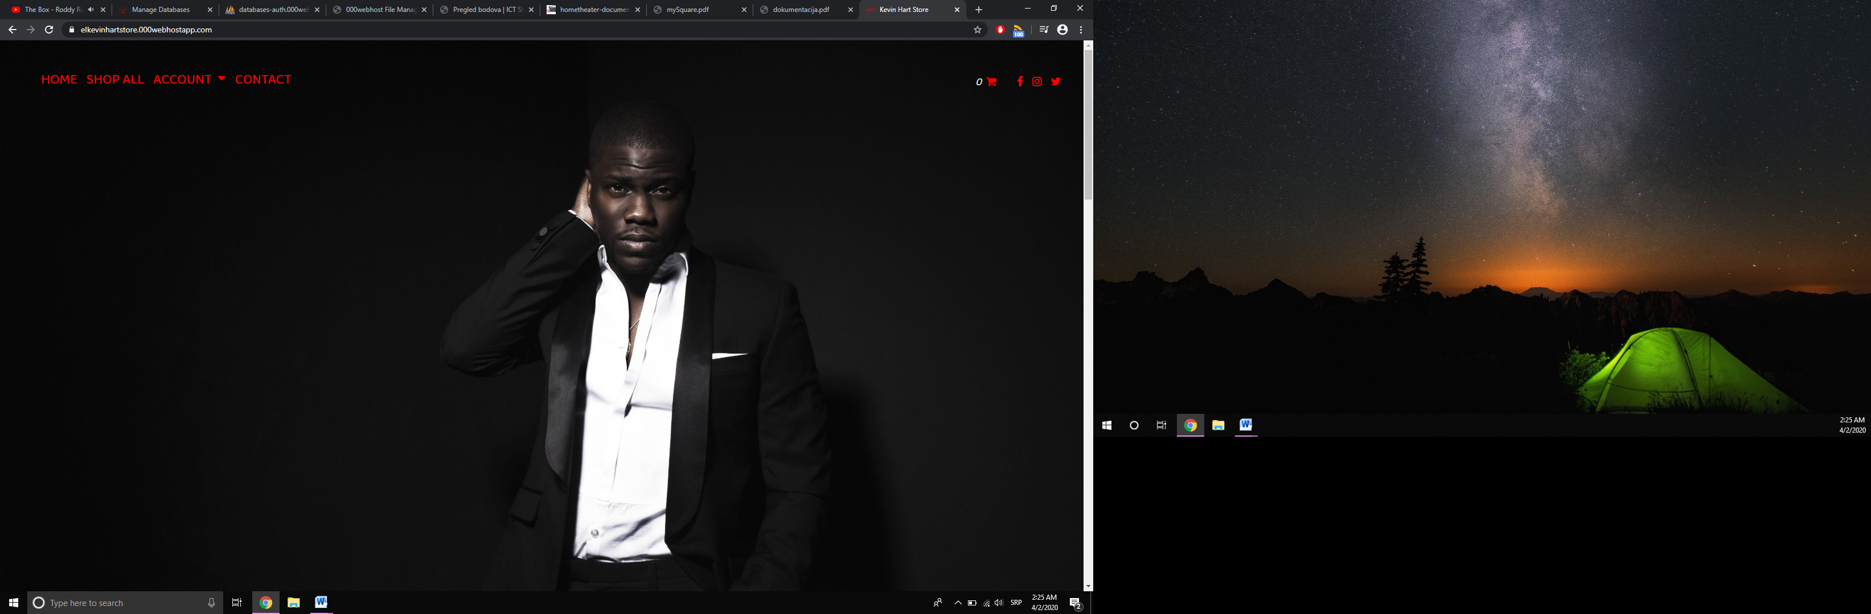

**INDEX.PHP**

**.mreze**

**nav.php**

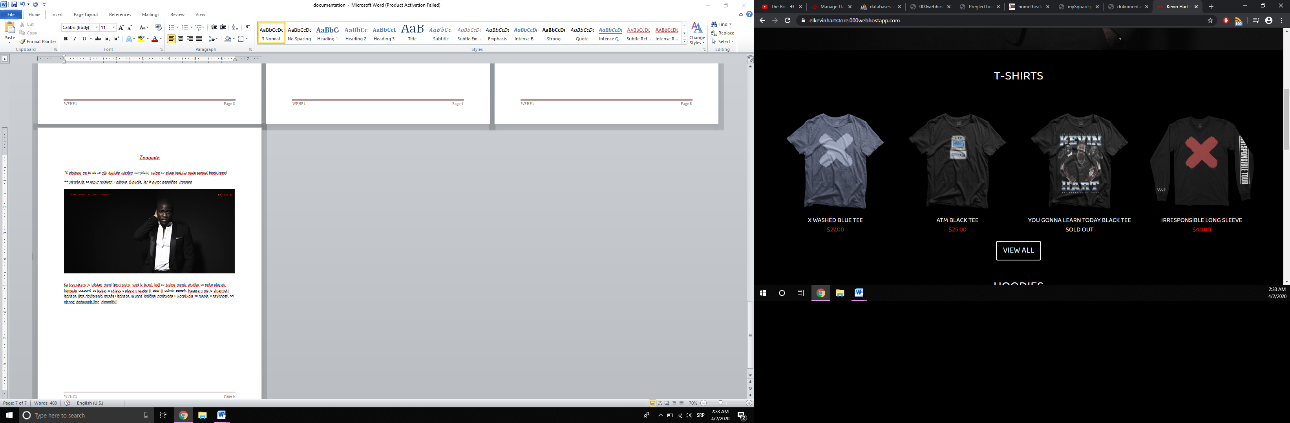Sa leve strane je izlistan meni (prethodno uzet iz baze), koji se jedino menja ukoliko se neko uloguje (umesto ***account*** se ispiše, u skladu s ulogom osobe ili ***user*** ili ***admin panel***). Naspram nje je dinamički ispisana lista društvenih mreža I ukupna količina proizvoda u korpi koja se menja u zavisnosti od njenog dodavanja(isto dinamički).

**home.php**

Prva četiri proizvoda iz kategorija **T-shirts** (koji takođe ima dodatnu opciju da klikom na ***view all*** prikaže sve proizvode iz te kategorije) I **Hoodies** se ispisuje na **home.php** stranici pomoću baze. Pojedinačnim klikom se prikazuju detalji svakog, ali za to ne menjajte kanal.

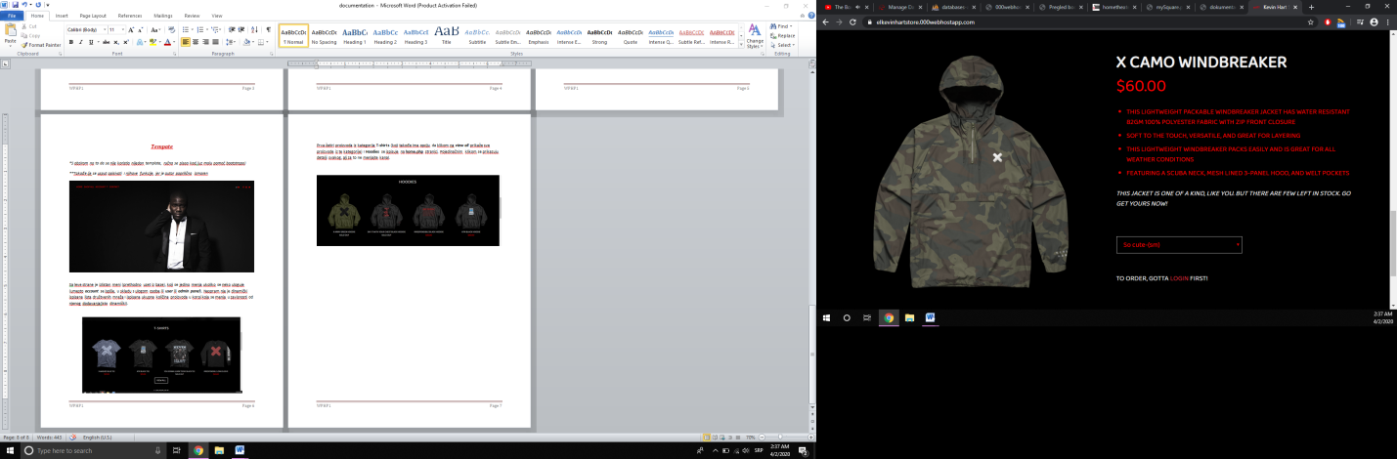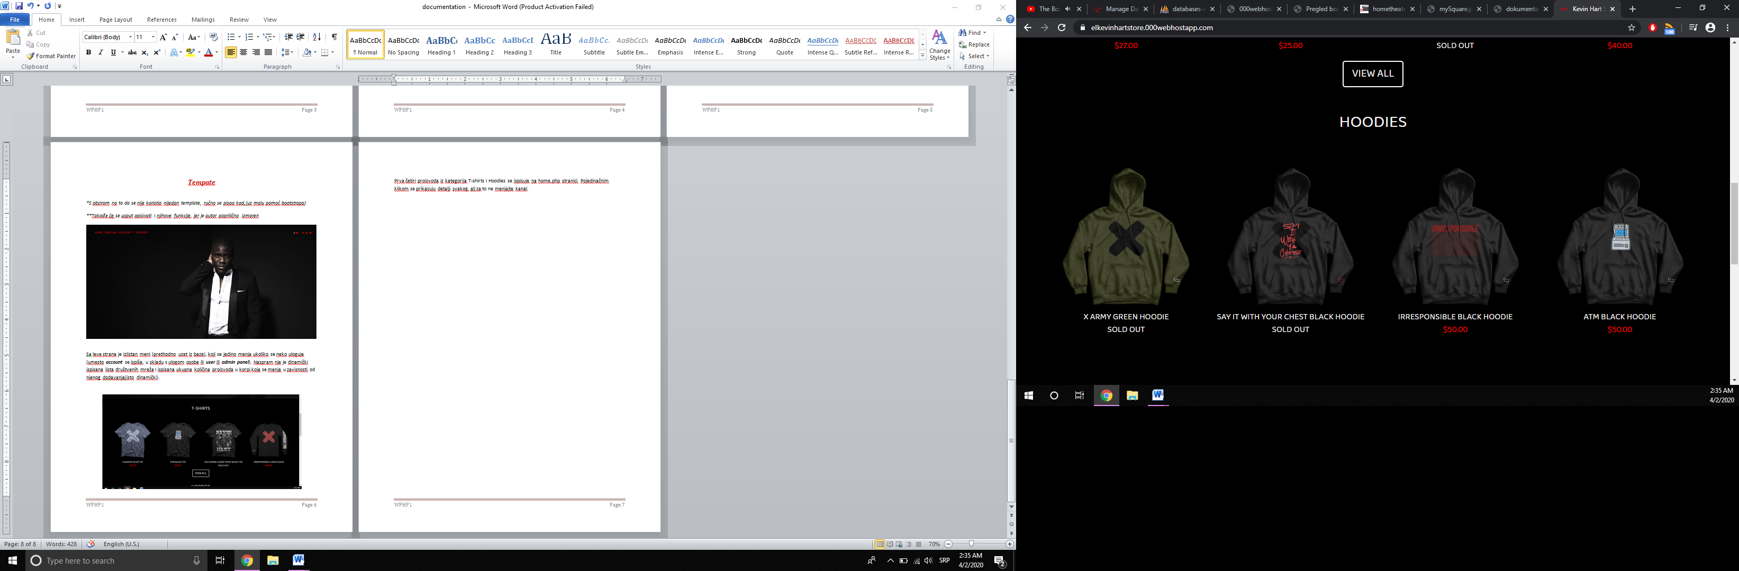

**home.php**

**home.php**

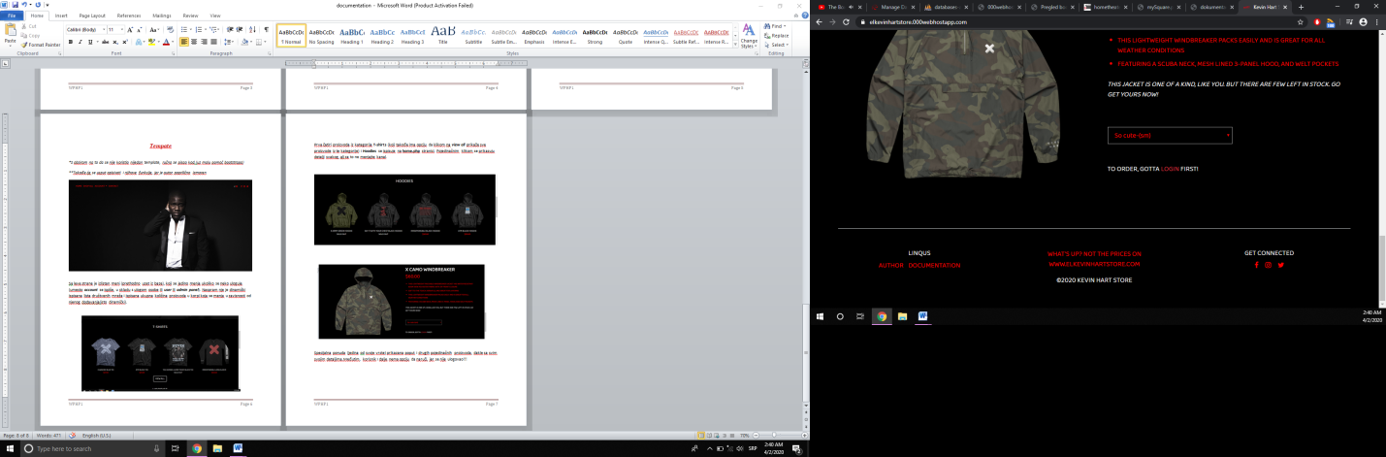Specijalna ponuda (jedina od svoje vrste) prikazana poput I drugih pojedinačnih proizvoda, dakle sa svim svojim detaljima(naravno,iz baze).Međutim, korisnik I dalje nema opciju da naruči, jer se nije ulogovao!!!

**.mreze**

**footer.php**

**author.php**

Kratak opis 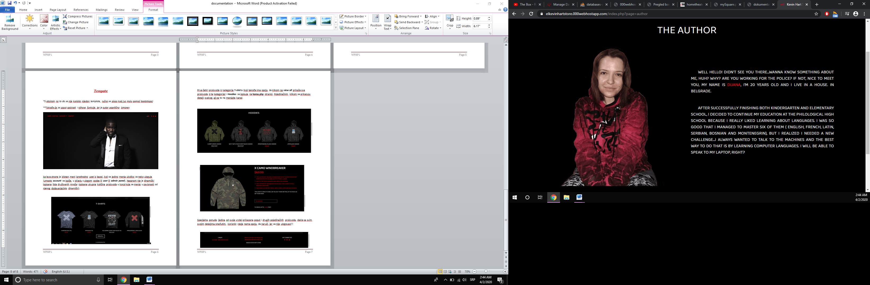(remek) dela.

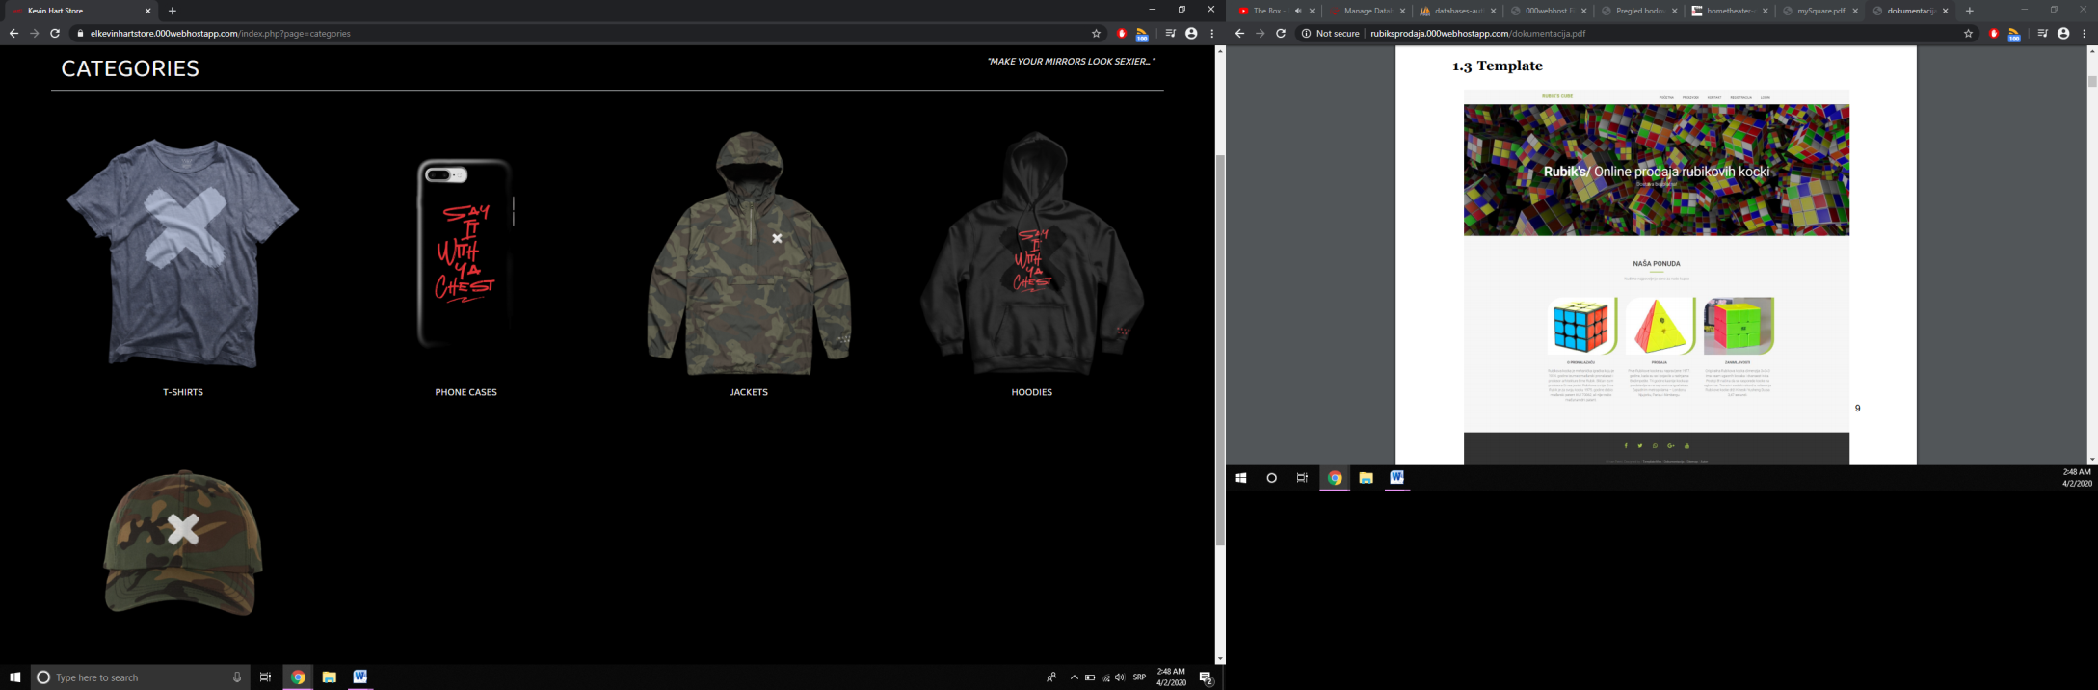

**categories.php**

Ispis svih kategorija (dovučen iz baze). Elem, ukoliko se klikne na neku od njih:

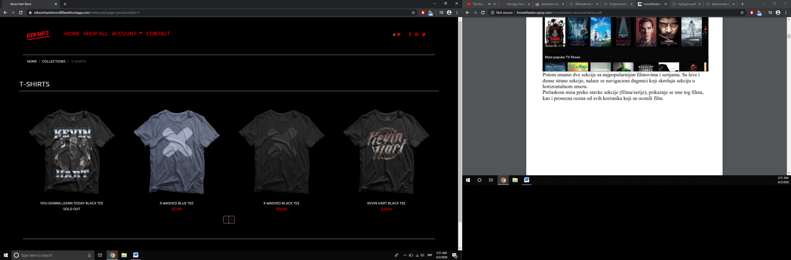

**products.php**

Ispisuju se po četiri proizvoda ( s naglaskom na **SOLD OUT**, ukoliko **NIJEDAN** nije na stanju vise, što saznajemo naravno na osnovu baze). Ostatak se paginacijom, pojavljuje, zamenjujući mesta prethodnicima.

**product.php**

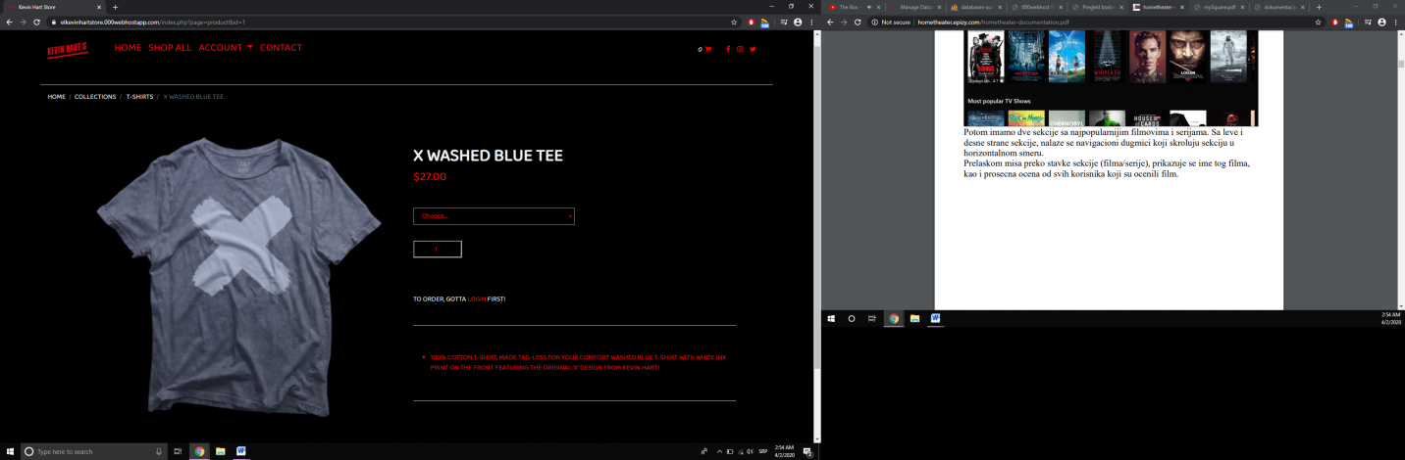

Detalji svakog proizvoda na jednom mestu (iz baze), među kojima su : njegova slika, naziv, cena, veličine I opis, naravno ispisane sve iz baze.

**product.php**

*\*Mini meni, takođe iz baze dohvaćen, omogućava iole lakše kretanje kroz sajt, u zavisnosti od proizvoda*

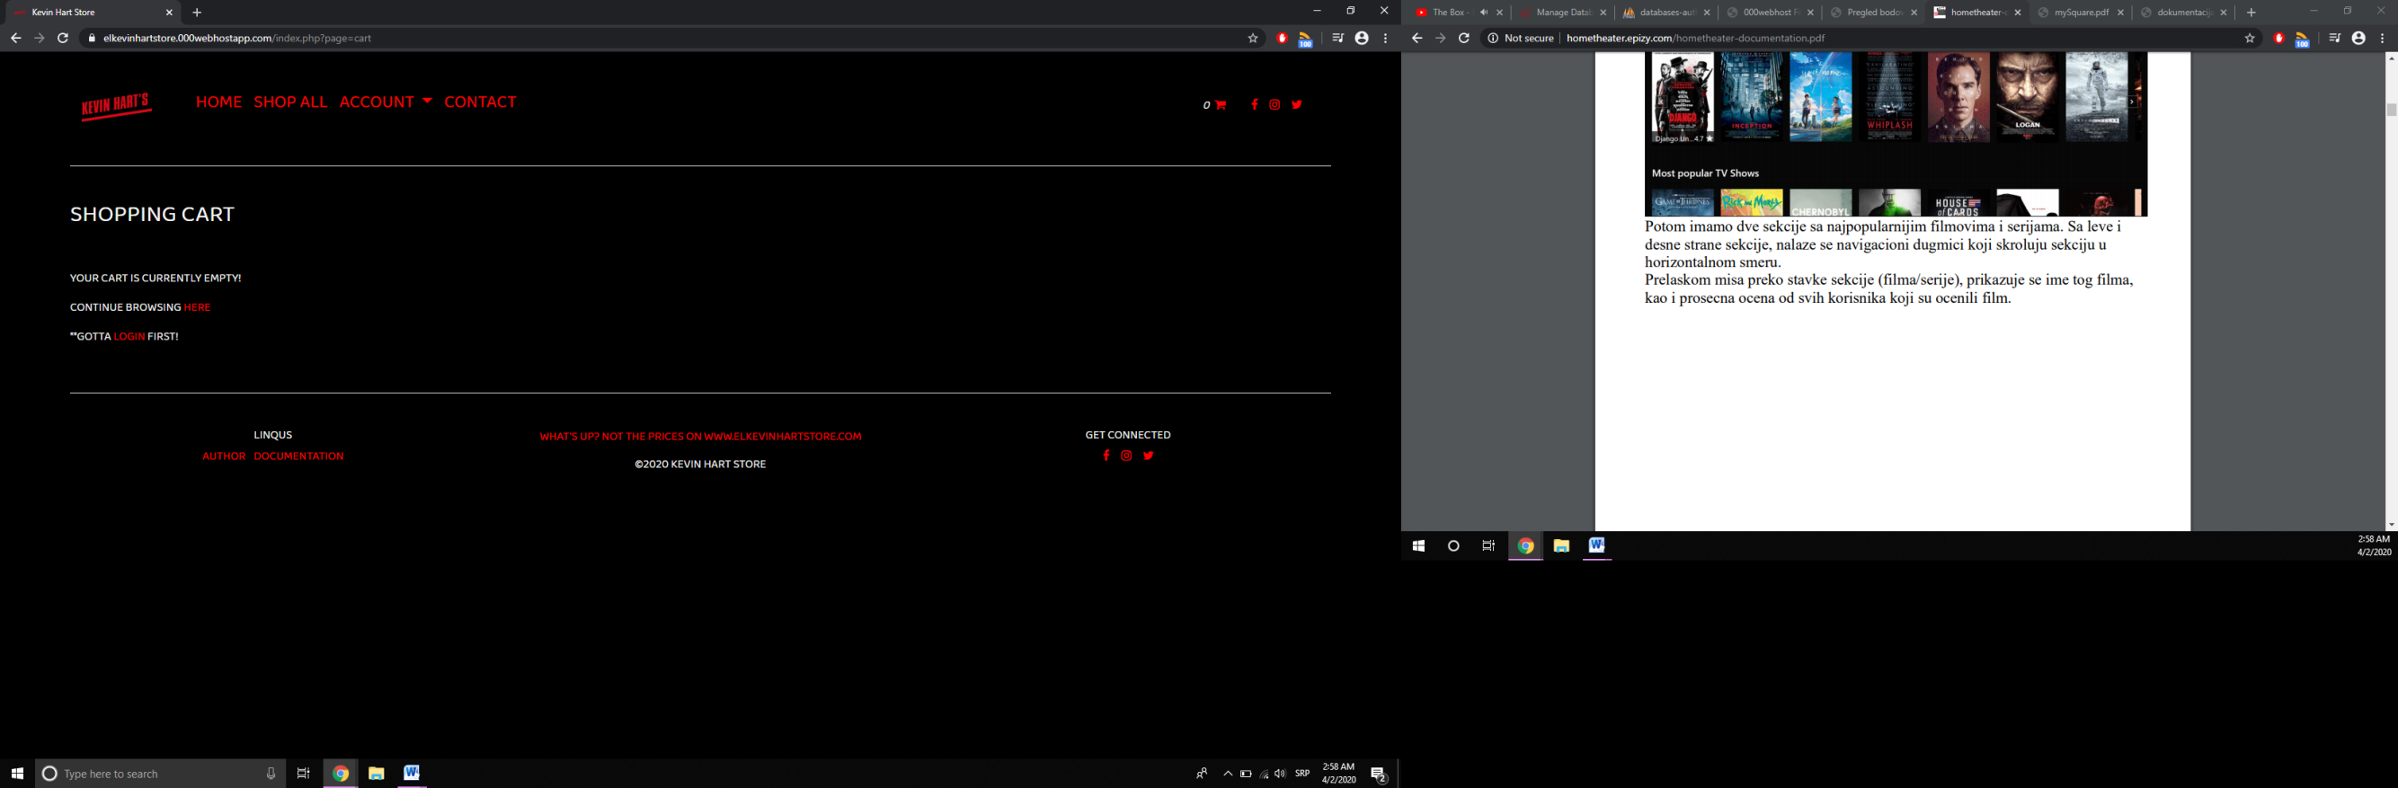

**korpa.php**

Korpica I dalje neostupna, jer kao što smo do sad zaključili, ukoliko se ne ulogujemo, ne možemo ni da je vidimo/koristimo.

**#navigacija**

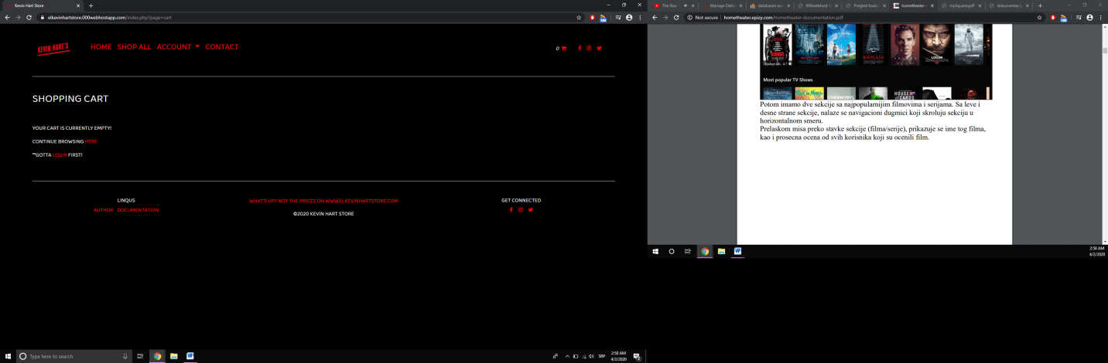

**#logo**

*\*\*Meni se menja na svim drugim stranicama (dobija* ***logo*** *sličicu, za razliku na* ***home.php*** *stranici)*

ULOGOVAN KORISNIK

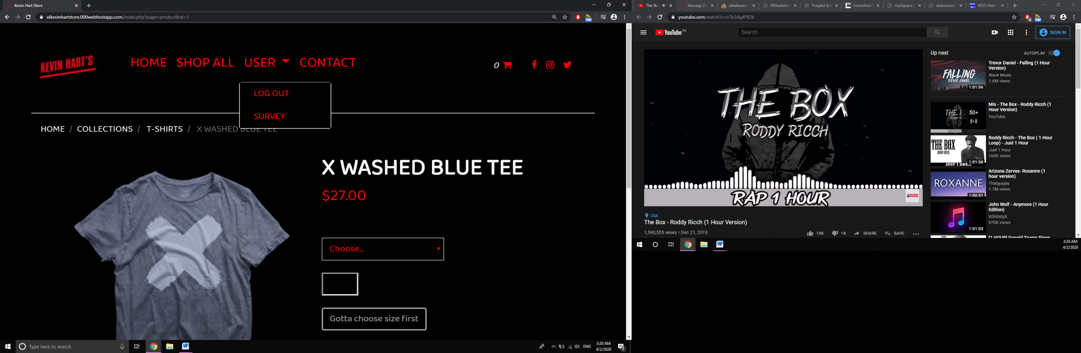

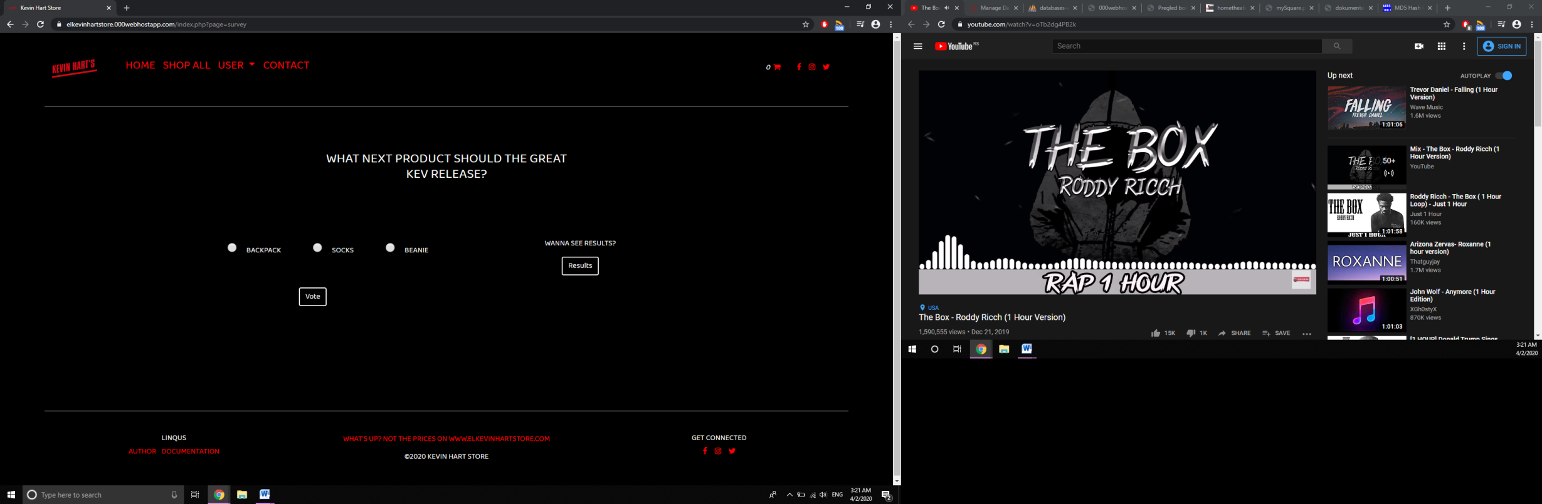

**anketa.php**

Sad, zahvaljujućI svojim privilegijama, korisnik može da odgovori na anketu I vidi sve rezultate:

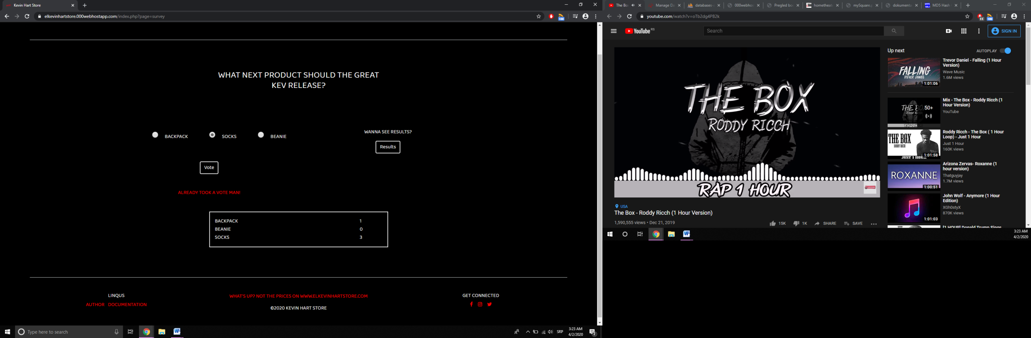

*\*\*Ukoliko je već glasao, prikazuje mu se obaveštenje. U suprotnom, zanimljiva poštapalica praćena sličicom kao znak potvrde.*

Ovaj sadržaj menja svoj izgled nakon logovanja, dobivši opciju ubacivanja proizvoda u korpu, ukoliko pre toga izabere veličinu (do tada je *disabled*). Dinamički se menjajući ih, ispisuje da li je na stanju u toj veličini (**ADD TO CART**)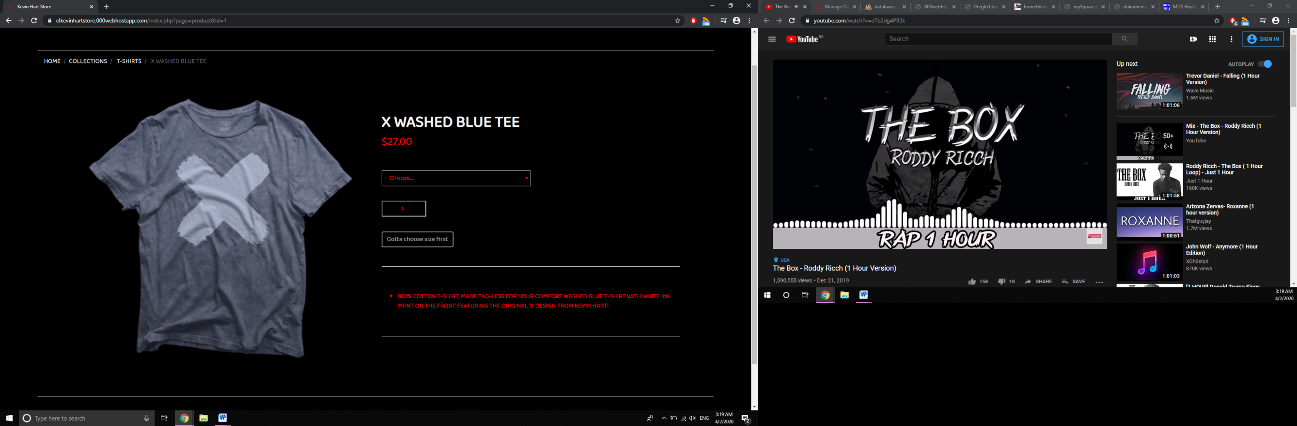 ili ne (**SOLD OUT**). Takođe, može da povećava/smanjuje količinu istog.

*\*\*Ukoliko proizvod nema veličinu (poput* ***PHONE CASES*** *ili* ***HATS****, ne prikazuje se lista sa veličinama).*

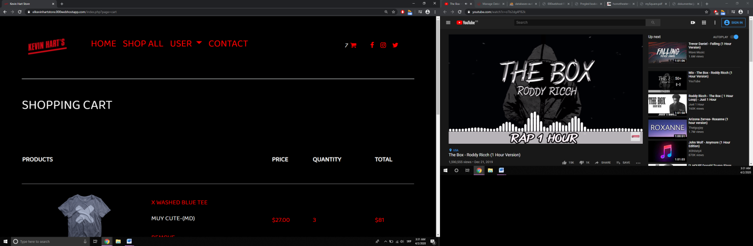

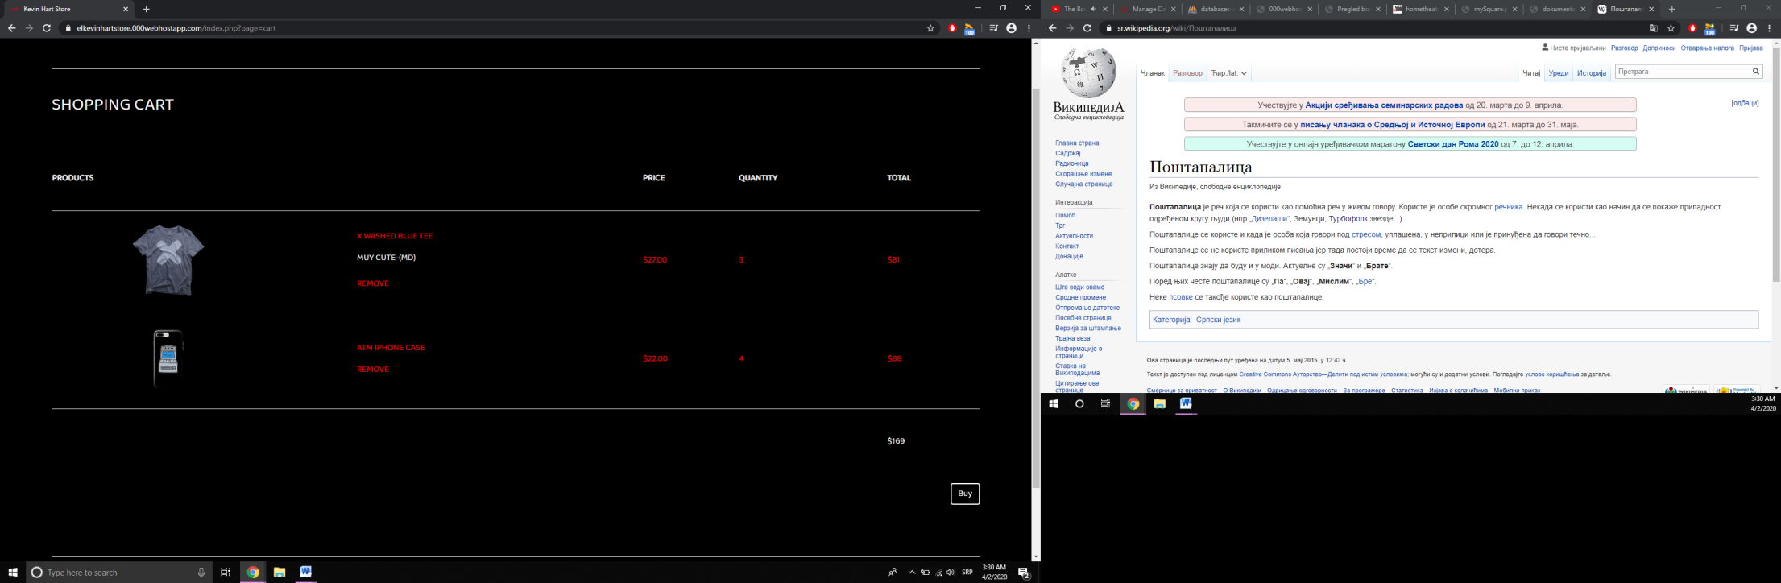

**korpa.php**

U korpi su prikazani detalji izabranih proizvoda za naručivanje, kao što su slika, naziv, veličina, količina, ukupna cena tog proizvoda i celokupne nabavke. Ukoliko želi, korisnik može da ukloni proizvod iz korpe.

*\*U meniju se ispisala ukupna količina u korpi i dinamički se uvek menja u zavisnosti od sadržine.*

*\*\*U slučaju da je korisnik kliknuo na dugme* ***BUY,*** *ispisalo mu se na dnu obaveštenje i ispraznila korpa.*

*DA BI SE DOŠLO DO SVEGA OVOGA MORA SE PROĆI KROZ OVE KORAKE:*

**register.php**

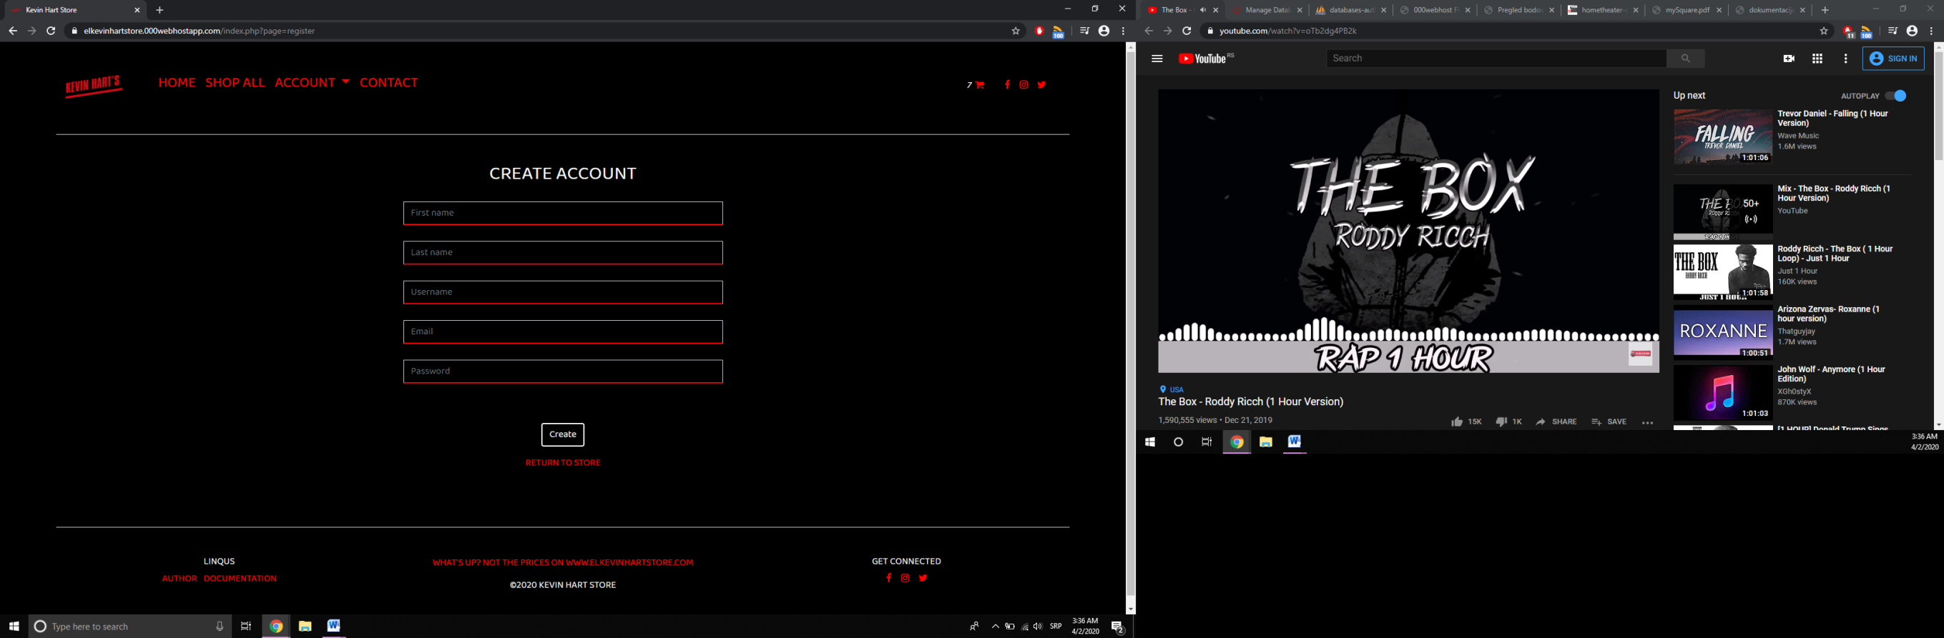

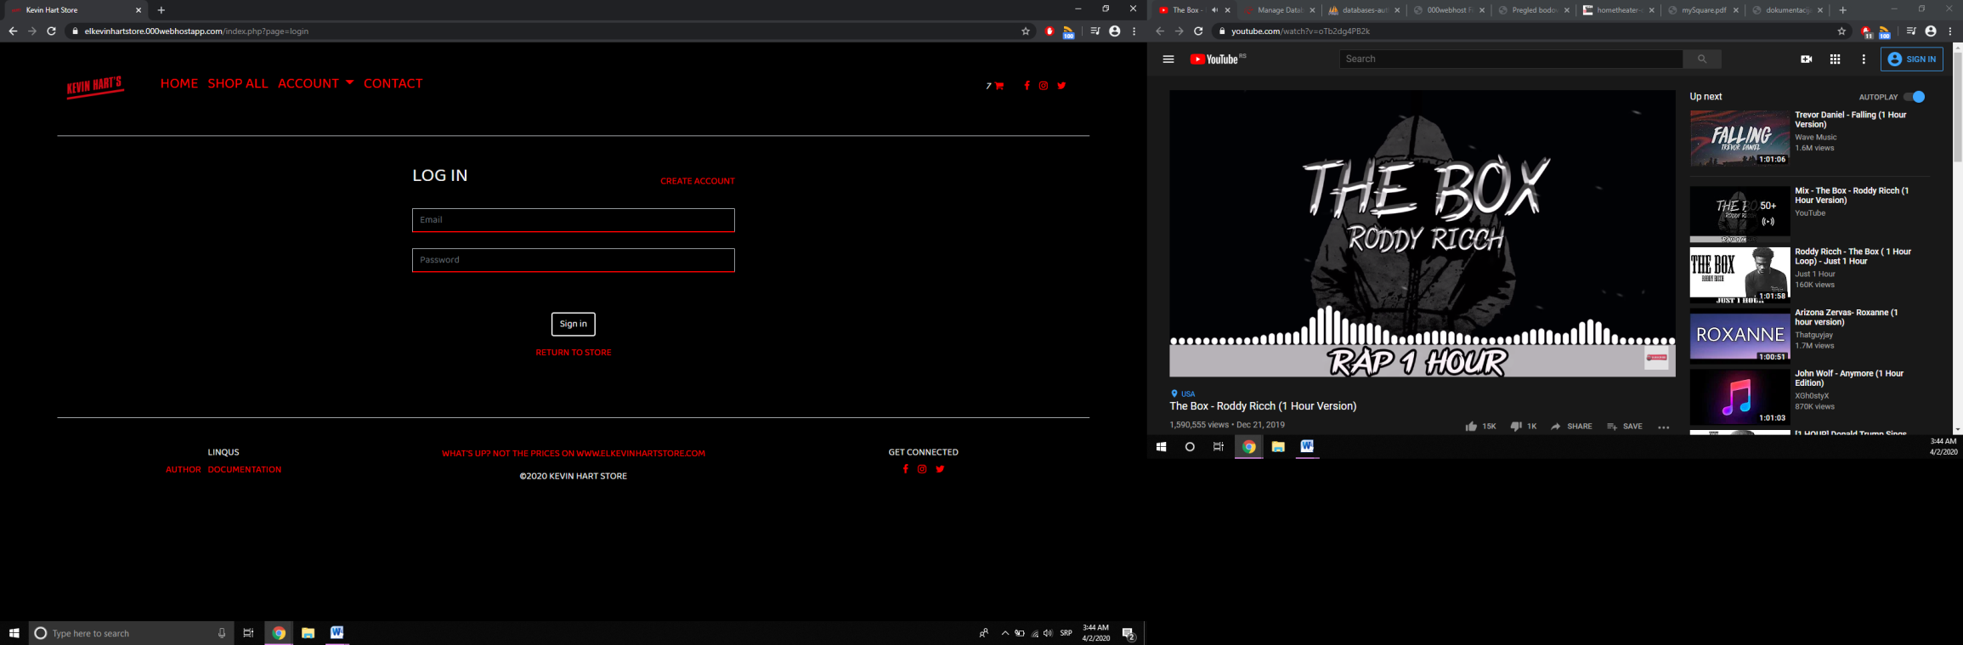Proveravaju se podaci na klijentskoj strani pomoću JS-a, potom ukoliko su korektni, šalju AJAX-om do contact.php stranice, koja ih takođe prekontroliše. Nakon graničnih provera, šalju se bazi i pravi se nalog

**login.php**

Za logovanje je takođe omogućena provera kod klijenta funkcijom koja sprečava direktno submitovanje forme ukoliko nije validna. U suprotnom se pravi sesija i transformiše sadržaj sajta.

**contact.php**

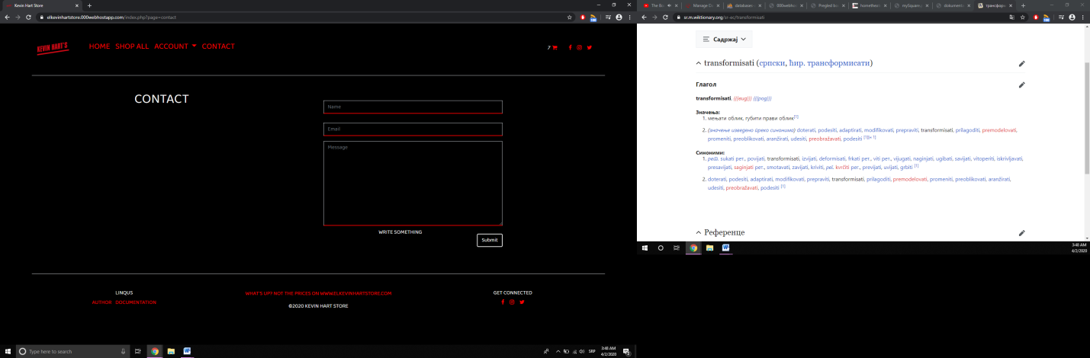

Ova stranica dopušta svakom posetiocu (bio on ulogovan ili ne) da pošalje poruku i time kontaktira administratora. Proveraju se podaci i shodno tome šalju bazi.

ULOGOVAN ADMINISTRATOR

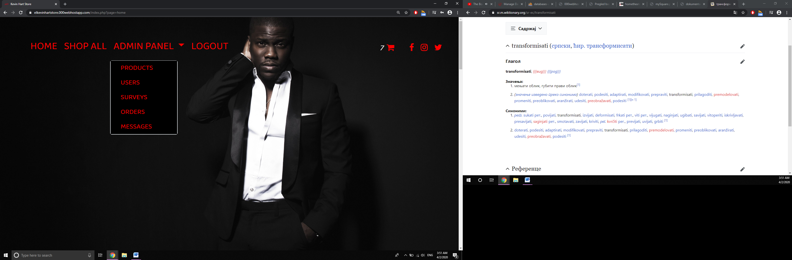

**products.php**

Izlistani svi proizvodi po redu kakvim kategorijama pripadaju. Njihova dostupnost u veličinama je obojena u skladu sa tim. Kraj 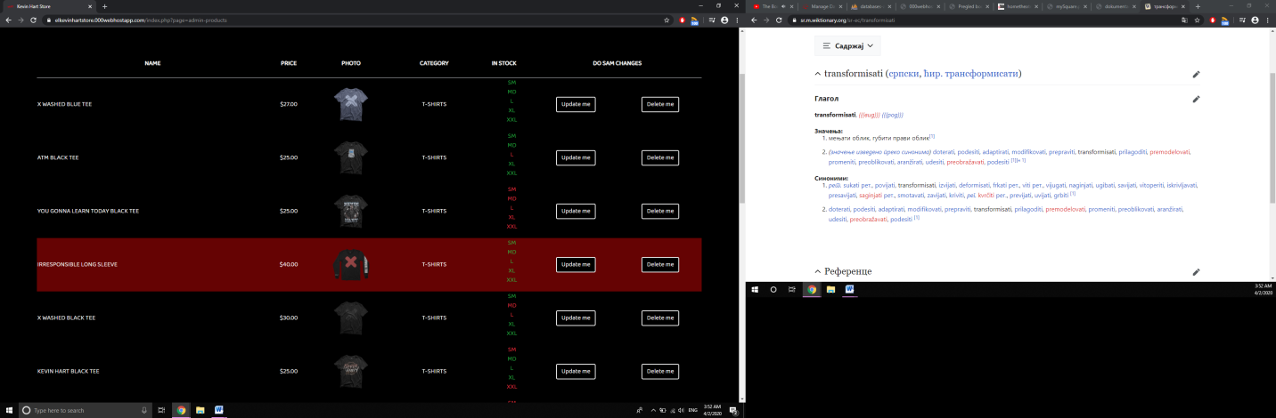toga su dve moguće opcije manipulisanja njima- promena i brisanje.

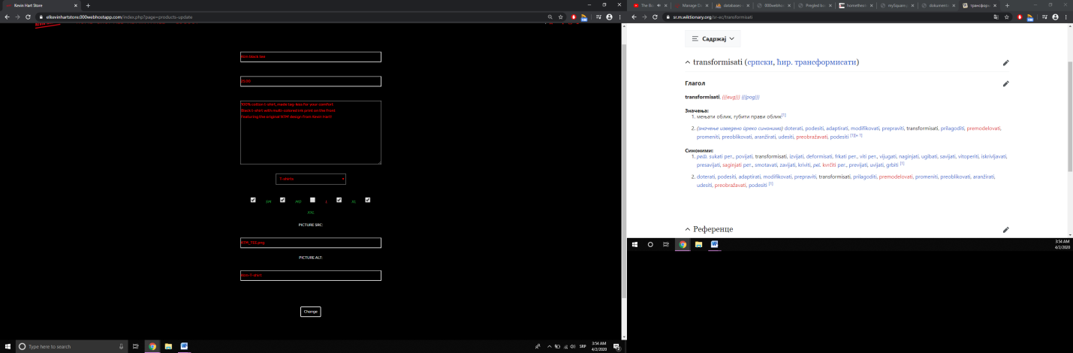

**update.php**

Izabrali ste **UPDATE**? Ne brinite, popunili su se direktno svi podaci tog proizvoda u formi, na vama je samo da birate šta ćete da menjate. Obrisali ste? (kao što je moj brat tako da izvinite na poslednjoj majici što je izrod i poslednji dodat proizvod i time ispao iz toka, kao i ja iz takta...)

U gornjem levom uglu je polunaslov/polulink koji otvara novu stranicu sa formom u skladu sa očekivanjem:

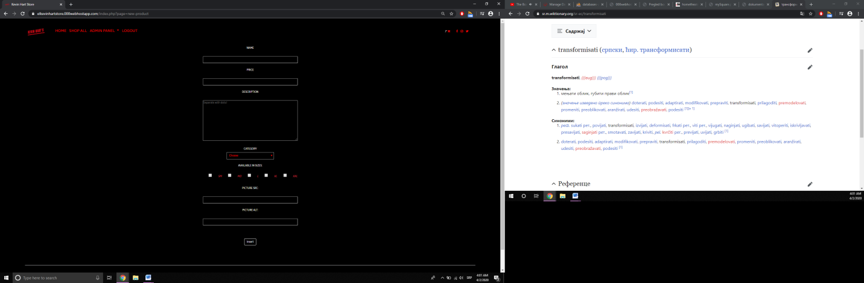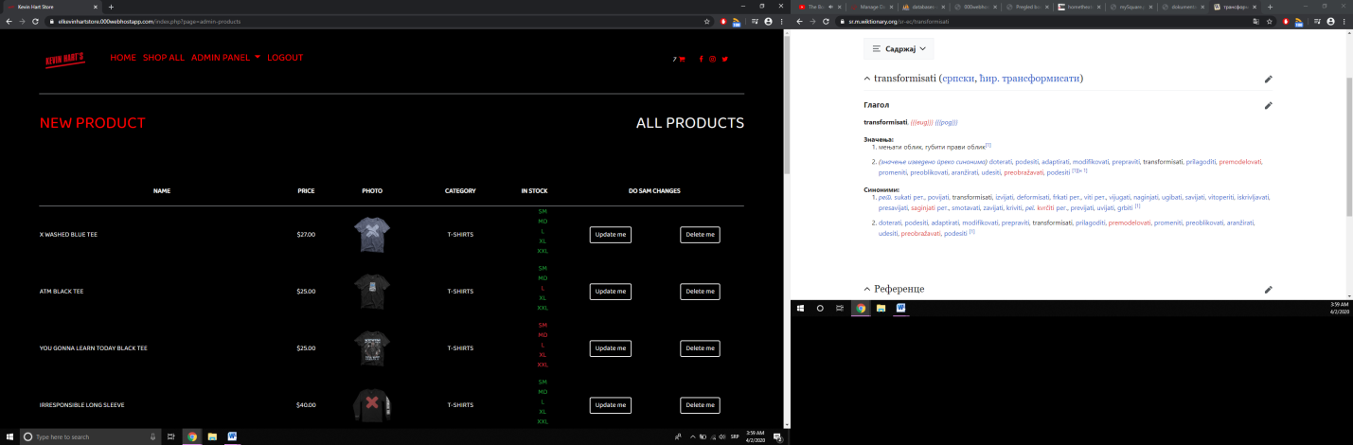

**new.php**

Proveravaju se podaci i AJAX-om šalju products/insert.php stranici koja takođe istu funkciju vrši.

*\*\*Ukoliko se izabere kategorija koja nema veličine, checkboxovi sa njima se sklanjaju i šalju kao null*

**users.php**

Uvid u korisnike, njihove detalje i uloge. Admin može da ih izbriše ili izmeni:

*\*\*Direkt iz baze popunjeni:*

**update.php**

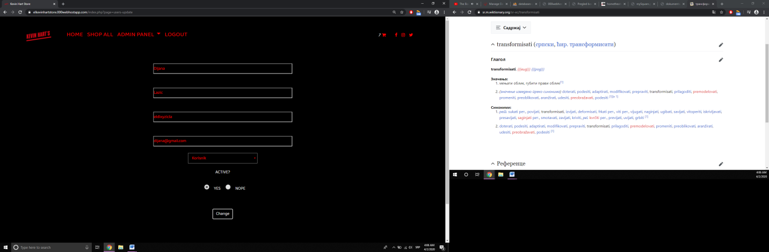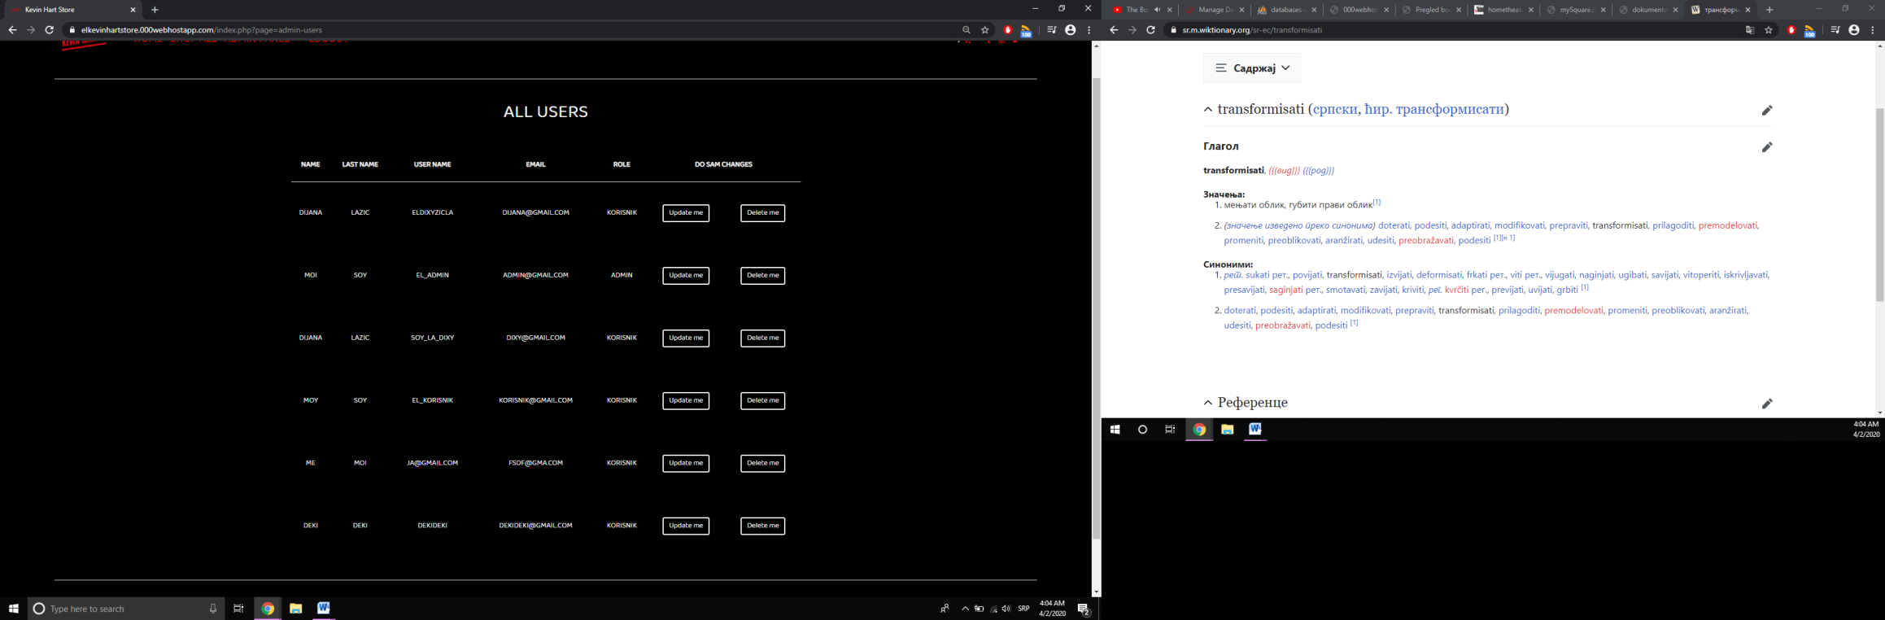

**surveys.php**

Sve u vezi sa anketama ovog sajta na jednom mestu. Unos nove, (de)aktiviranje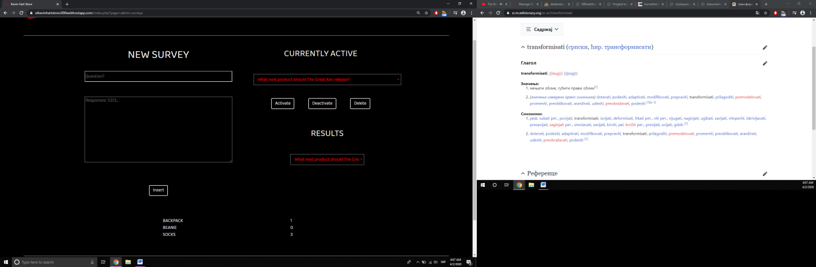 postojećih, kao i njihovo brisanje i prikaz rezultata.

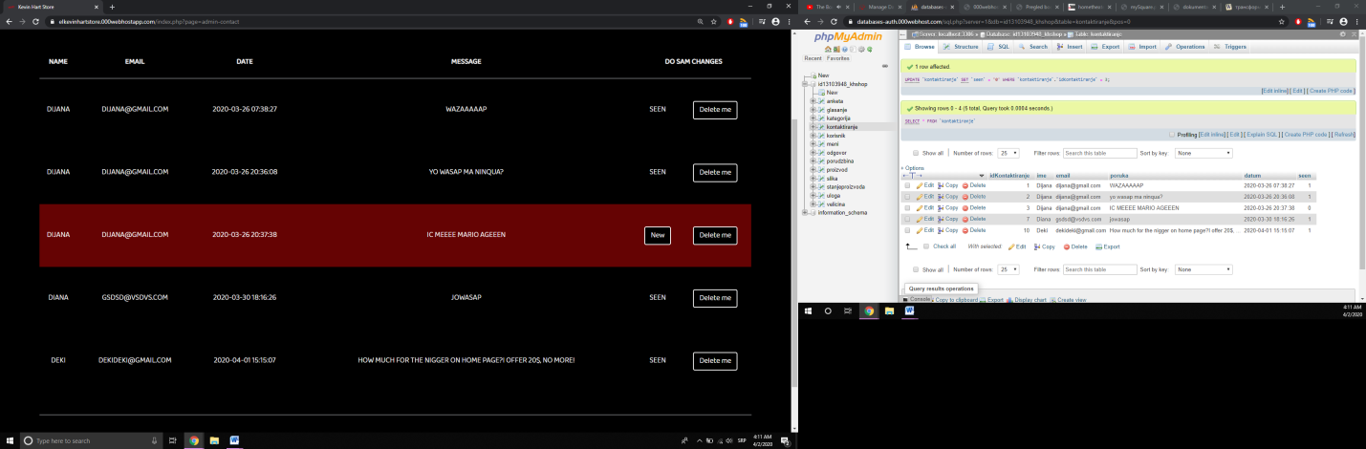*\*\*Samo JEDNA može biti trenutno aktivna!!!*

**contact.php**

Novopristigle poruke imaju opciju da se *„seen-uju“,*a svaka ponaosob i da se obriše od strane admina.

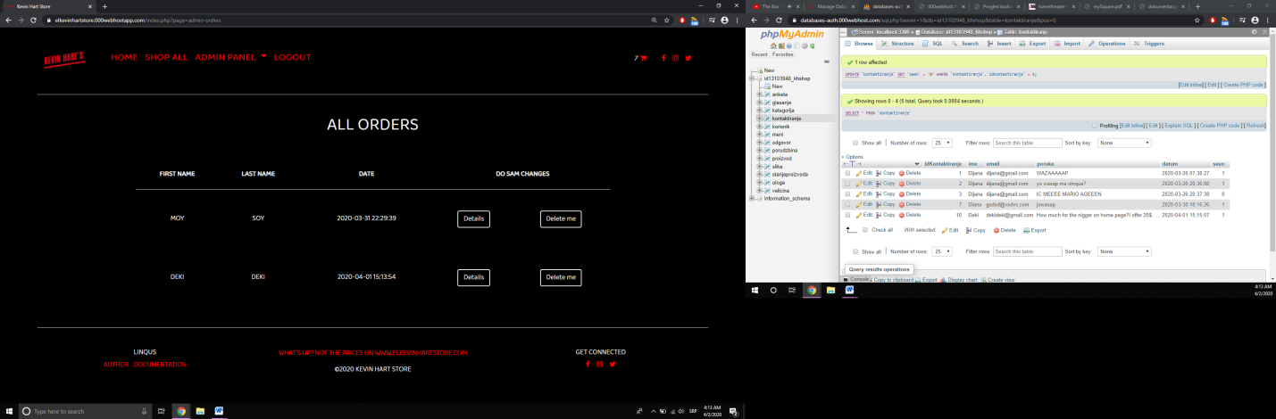

**orders.php**

Narudžbine svakog od korisnika prikazane na prethodnoj slici ukazuju na to da mogu se vide detalji tj konkretni sadržaji svake. Otud, klikom na **DETAILS ,**skoči modal sa podacima poput ovog:

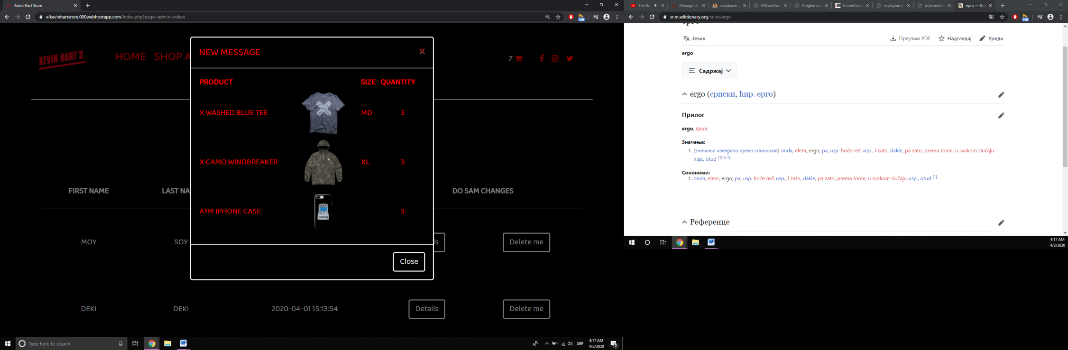

**#detalji-por**

*\*\*Brisanjem narudžbine se briše* ***SVE*** *što je korisnik hteo da kupi!!!*

# Organizacija

## *Organizaciona šema:*

**baze**

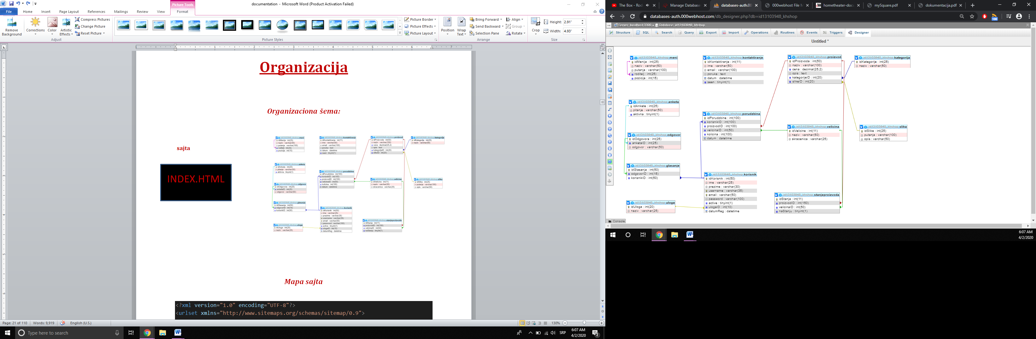

### sajta

INDEX.HTML

## *Mapa sajta*

<?xml version="1.0" encoding="UTF-8"?>

<urlset xmlns="http://www.sitemaps.org/schemas/sitemap/0.9">

<url>

<loc>https://elkevinhartstore.000webhostapp.com/index.php</loc>

<lastmod>2020-02-25</lastmod>

<changefreq>yearly</changefreq>

<priority>1.00</priority>

</url>

</urlset>

# Kodovi

**1)INDEX.PHP-HOME PAGE**

<?php

session_start();

ob_start();

require_once("config/connection.php");

require_once("modules/functions.php");

require_once("views/fixed/head.php");

//navigacioni meni

if (isset($_GET["page"])) :

$page = $_GET["page"];

if ($page == "home") : ?>

<nav class="navbar navbar-expand-lg navbar-light h1 mb-5 pt-5" id="navigacija">

<?php require_once("views/fixed/nav.php"); ?>

</nav>

<?php else : ?>

<div class="omotac mb-3">

<nav class="navbar navbar-expand-lg navbar-light mb-5 pt-5 container-fluid">

<a href="index.php">

<img src="assets/img/LOGO.png" alt="Logo" class="manje" title="Home page">

</a>

<?php require_once("views/fixed/nav.php"); ?>

</nav>

</div>

<?php endif ?>

<?php else : ?>

<nav class="navbar navbar-expand-lg navbar-light h1 mb-5 pt-5 " id="navigacija">

<?php require_once("views/fixed/nav.php"); ?>

</nav>

<?php endif ?>

<!--sadrzaj -->

<?php

if (isset($_GET['page'])) {

$page = $_GET['page'];

switch ($page) {

case 'home':

require_once("views/fixed/home.php");

break;

case 'categories':

require_once("views/pages/categories.php");

break;

case 'products':

require_once("views/pages/products.php");

break;

case 'product':

require_once("views/pages/product.php");

break;

case 'contact':

require_once("views/pages/contact.php");

break;

case 'register':

require_once("views/pages/register.php");

break;

case 'login':

require_once("views/pages/login.php");

break;

case 'logout':

require_once("modules/logout.php");

break;

case 'survey':

require_once("views/pages/korisnik/anketa.php");

break;

case 'cart':

require_once("views/pages/korisnik/korpa.php");

break;

case 'admin-products':

require_once("views/pages/admin/products/products.php");

break;

case 'admin-users':

require_once("views/pages/admin/users/users.php");

break;

case 'admin-surveys':

require_once("views/pages/admin/surveys/surveys.php");

break;

case 'admin-orders':

require_once("views/pages/admin/orders/orders.php");

break;

case 'admin-contact':

require_once("views/pages/admin/messages/contact.php");

break;

case 'products-update':

require_once("views/pages/admin/products/update.php");

break;

case 'users-update':

require_once("views/pages/admin/users/update.php");

break;

case 'new-product':

require_once("views/pages/admin/products/new.php");

break;

//najbolje za kraj

case 'author':require_once("views/pages/author.php");break;

default:

require_once("views/fixed/home.php");

break;

}

} else {

require_once("views/fixed/home.php");

}

?>

<!-- futer -->

<?php require_once("views/fixed/footer.php"); ?>

## *VIEWS*

**FIXED**

**1)HEAD.PHP**

<!DOCTYPE html>

<html lang="en">

<head>

<meta charset="UTF-8">

<meta name="viewport" content="width=device-width, initial-scale=1.0">

<meta http-equiv="X-UA-Compatible" content="ie=edge">

<meta name="keywords" content="store,t-shirts,hoodies,jackets,phone-cases,hats,Kevin,Hart"/>

<meta name="author" content="Dijana Lazic" target="_blank"/>

<meta name="description" content="I think you'll look very good in these...SO stop scrolling and get yourself one of kind clothing! "/>

<!--linkovi-->

<link rel="stylesheet" type="text/css" href="assets/bootstrap-4.3.1-dist/css/bootstrap.min.css"/>

<link rel="stylesheet" type="text/css" href="assets/css/style.css"/>

<link rel="shortcut icon" href="assets/img/short.ico"/>

<link rel="stylesheet" href="https://cdnjs.cloudflare.com/ajax/libs/font-awesome/4.7.0/css/font-awesome.min.css">

<title>Kevin Hart Store</title>

</head>

**2)NAV.PHP**

<?php ?>

<button class="navbar-toggler bg-danger" type="button" data-toggle="collapse" data-target="#navbarSupportedContent" aria-controls="navbarSupportedContent" aria-expanded="false" aria-label="Toggle navigation">

<span class="navbar-toggler-icon "></span>

</button>

<div class="collapse navbar-collapse" id="navbarSupportedContent">

<ul class="navbar-nav mr-auto ml-5">

<?php

$rmeni = $conn->query("select * from meni where roditelj is null order by pozicija")->fetchAll();

foreach ($rmeni as $rm) :

if ($rm->naziv == "Account") {

if (isset($_SESSION['korisnik'])) {

continue;

}

}

if (($rm->naziv == "User")) {

if (!isset($_SESSION['korisnik'])) {

continue;

} elseif ($_SESSION['korisnik']->uloga == 'Admin') {

continue;

}

}

if ($rm->naziv == "Admin panel") {

if (!isset($_SESSION['korisnik'])) {

continue;

} elseif ($_SESSION['korisnik']->uloga == 'Korisnik') {

continue;

}

}

if ($rm->naziv == "Contact") {

if (isset($_SESSION['korisnik']) && ($_SESSION['korisnik']->uloga == 'Admin')) {

continue;

}

}

if ($rm->putanja == "#") {

$rpodmeni = $conn->prepare("SELECT * FROM meni WHERE roditelj=:roditelj ORDER BY pozicija");

$rpodmeni->bindParam(":roditelj", $rm->idMenija);

$rpodmeni->execute();

if ($rpodmeni->rowCount() > 0) {

$rpodmeni = $rpodmeni->fetchAll();

echo "<li class='nav-item dropdown '>

<a class='nav-link crveno h4 dropdown-toggle' href='$rm->putanja' id='navbarDropdown' role='button' data-toggle='dropdown' aria-haspopup='true' aria-expanded='false'>

$rm->naziv

</a><div class='dropdown-menu border' aria-labelledby='navbarDropdown'>";

foreach ($rpodmeni as $rpm) {

echo "<a class='dropdown-item crveno py-2 crno' href='$rpm->putanja'>$rpm->naziv</a>";

}

}

} else {

echo "<li class='nav-item active'>

<a class='nav-link crveno h4' href='$rm->putanja'> $rm->naziv <span class='sr-only'>(current)</span></a>

</li>";

}

endforeach ?>

<?php

if (isset($_SESSION['korisnik']) && ($_SESSION['korisnik']->uloga == 'Admin')) {

echo "<li class='nav-item active'>

<a class='nav-link crveno h4' href='index.php?page=logout'> Logout <span class='sr-only'>(current)</span></a>

</li>";

}

?>

</ul>

<div class="mr-3 mreze ml-5">

<a href="index.php?page=cart" title=”Shopping cart”>

<i id="ukorpi"></i>

<i class="crveno fa fa-shopping-cart ml-1 mr-4" aria-hidden="true"></i>

</a>

</div>

</div>

**3)HOME.PHP**

<div id="slajder"></div>

<div class="omotac">

<div class="row my-5">

<h1 class="mx-auto h2">T-shirts</h1>

</div>

<?php

$upit = $conn->query("select k.naziv as katnaz, p.idProizvoda as pId,p.naziv as pnaz,p.cena as pcena,s.putanja as sput,s.opis as altic from kategorija k inner join proizvod p on k.idKategorije=p.kategorijeID inner join slika s on p.slikeID=s.idSlike inner join stanjeproizvoda pv on p.idProizvoda=pv.proizvodID where k.naziv='T-shirts' group by p.naziv order by p.idProizvoda limit 4 ")->fetchAll(); ?>

<div class="row text-center">

<?php foreach ($upit as $red) : ?>

<div class="col-lg-3">

<a href="index.php?page=product&id=<?= $red->pId ?>">

<figure>

<img src="assets/img/<?= $red->sput ?>" alt="<?= $red->altic ?>" class="w-100">

<caption><?= $red->pnaz ?>

<?php $imal = $conn->prepare("SELECT sp.naStanju as ima FROM proizvod p inner JOIN stanjeproizvoda sp on p.idProizvoda=sp.proizvodID where p.idProizvoda=:id group by p.idProizvoda,sp.naStanju order by sp.naStanju desc");

$id = $red->pId;

$imal->bindParam(":id", $id);

$imal->execute();

foreach ($imal as $i) :

?>

<?php if ($i->ima == 1) : ?>

<p class="crveno">$<?= $red->pcena ?></p>

<?php break; ?>

<?php else : ?>

<p>Sold out</p>

<?php endif ?>

<?php endforeach; ?>

</caption>

</figure>

</a>

</div>

<?php endforeach ?>

</div>

<div class="row">

<a href="index.php?page=products&id=1" class="btn btn-lg active mx-auto" role="button" aria-pressed="true">View all</a>

</div>

<div class="row my-5 ">

<h2 class="mx-auto">Hoodies</h2>

</div>

<?php

$upit = $conn->query("select k.naziv as katnaz,s.putanja as sput,s.opis as altic,p.idProizvoda as pId,p.naziv as pnaz,p.cena as pcena from kategorija k inner join proizvod p on k.idKategorije=p.kategorijeID inner join slika s on p.slikeID=s.idSlike inner join stanjeproizvoda pv on p.idProizvoda=pv.proizvodID where k.naziv='Hoodies' group by p.naziv order by p.naziv desc limit 4")->fetchAll(); ?>

<div class="row text-center">

<?php foreach ($upit as $red) : ?>

<div class="col-lg-3">

<a href="index.php?page=product&id=<?= $red->pId ?>">

<figure>

<img src="assets/img/<?= $red->sput ?>" alt="<?= $red->altic ?>" class="w-100">

<caption><?= $red->pnaz ?>

<?php $imal = $conn->prepare("SELECT sp.naStanju as ima FROM proizvod p inner JOIN stanjeproizvoda sp on p.idProizvoda=sp.proizvodID where p.idProizvoda=:id group by p.idProizvoda,sp.naStanju order by sp.naStanju desc");

$id = $red->pId;

$imal->bindParam(":id", $id);

$imal->execute();

foreach ($imal as $i) :

?>

<?php if ($i->ima == 1) : ?>

<p class="crveno">$<?= $red->pcena ?></p>

<?php break; ?>

<?php else : ?>

<p>Sold out</p>

<?php endif ?>

<?php endforeach; ?>

</figure>

</a>

</div>

<?php endforeach ?>

</div>

<?php

$jedinac = $conn->query("select p.idProizvoda as pId,p.naziv as pnaz,p.cena as pcena,p.opis as popis,s.putanja as sput,s.opis as altic from proizvod p inner join slika s on p.slikeID=s.idSlike inner join kategorija k on p.kategorijeID=k.idKategorije inner join stanjeproizvoda pv on p.idProizvoda=pv.proizvodID where k.naziv='Jackets' group by p.naziv order by p.naziv desc limit 1")->fetch(); ?>

<div class="row my-5 py-5">

<div class="col-lg-6">

<a href="index.php?page=product&id=<?= $jedinac->pId ?>">

<img src="assets/img/<?= $jedinac->sput ?>" alt="<?= $jedinac->altic ?>" class="w-100 nopa">

</a>

</div>

<div class="col-lg-6 my-auto">

<p class="pl-3 h1 font-weight-bold"><?= $jedinac->pnaz ?></p>

<?php $imal = $conn->prepare("SELECT sp.naStanju as ima FROM proizvod p inner JOIN stanjeproizvoda sp on p.idProizvoda=sp.proizvodID where p.idProizvoda=:id group by p.idProizvoda,sp.naStanju order by sp.naStanju desc");

$id = $jedinac->pId;

$imal->bindParam(":id", $id);

$imal->execute();

foreach ($imal as $i) :

?>

<p class="crveno mb-4 pl-3 h1">

<?php if ($i->ima == 1) : ?>

$<?= $jedinac->pcena ?>

<?php break; ?>

<?php else : ?>

Sold out

<?php endif ?>

</p>

<?php endforeach; ?>

<ul class="crveno">

<?php

$opis = $jedinac->popis;

$pojedinacniOpisi = explode(".", $opis);

foreach ($pojedinacniOpisi as $pOp) {

echo "<li class='my-2'>$pOp</li>";

}

?>

</ul>

<p class="mt-4 pl-3 "><i>This jacket is one of a kind, like you. But there are few left in stock. Go get yours now!</i></p>

<!-- velicine -->

<?php

$velicine = $conn->query("select * from velicina")->fetchAll(); ?>

<select name="" id="velicine" class="my-5 ml-3">

<?php foreach ($velicine as $v) : ?>

<option value="<?= $v->idVelicine ?>"><?= $v->naziv ?>-(<?= $v->skracenica ?>)</option>

<?php endforeach ?>

</select><br>

<?php if (isset($_SESSION['korisnik'])) : ?>

<button type="button" id="dodajUkorpu" data-idproizvoda="<?= $jedinac->pId ?>" class="btn btn-dark my-5 ml-3">Add to cart</button>

<?php else : ?>

<p class="ml-3">To order, gotta <a href="index.php?page=login" class="text-danger">login</a> first!</p>

<?php endif ?>

</div>

</div>

</div>

**4)FOOTER.PHP**

<div class="omotac my-5 border-top">

<div class="row text-center pt-5">

<div class="col-lg-4 ">

<h6>Linqus</h6>

<ul class=" list-inline">

<li class="list-inline-item"><a href="index.php?page=author" class="crveno">Author</a></li>

<li class="list-inline-item"><a href="documentation.pdf" class="crveno" target="_blank">Documentation</a></li>

</ul>

</div>

<div class="col-lg-4 ">

<p class="crveno">What's up? Not the prices on www.elkevinhartstore.com </p>

<h6>&copy;2020 Kevin Hart Store</h6>

</div>

<div class="col-lg-4 mreze">

<h6>Get connected</h6>

</div>

</div>

</div>

<script src="https://code.jquery.com/jquery-3.4.1.js"></script>

<script src="assets/js/main.js"></script>

<script type="text/javascript" src="assets/bootstrap-4.3.1-dist/js/bootstrap.min.js"></script>

**PAGES**

**1)CATEGORIES.PHP**

<div class="omotac">

<nav aria-label="breadcrumb">

<ol class="breadcrumb border-top py-3">

<li class="breadcrumb-item"><a href="index.php">Home</a></li>

<li class="breadcrumb-item active" aria-current="page">Collections</li>

</ol>

</nav>

<div class="row border-bottom my-5">

<div class="col-lg-6">

<h1>Categories</h1>

</div>

<div class="col-lg-6 text-right">

<p>

<i>"Make your mirrors look sexier... "</i>

</p>

</div>

</div>

<div class="row text-center my-5">

<?php $rkategorije = $conn->query("select k.idKategorije as kid,k.naziv as katnaz, p.idProizvoda as pId,p.naziv as pnaz,p.cena as pcena,s.putanja as sput,s.opis as altic from kategorija k inner join proizvod p on k.idKategorije=p.kategorijeID inner join slika s on p.slikeID=s.idSlike group by k.naziv order by k.naziv desc")->fetchAll(); ?>

<div class="row">

<?php foreach ($rkategorije as $rkat) : ?>

<div class="col-lg-3">

<a href="index.php?page=products&id=<?= $rkat->kid ?>">

<figure>

<img src="assets/img/<?= $rkat->sput ?>" alt="<?= $rkat->altic ?>" class="w-100">

<caption><?= $rkat->katnaz ?></caption>

</figure>

</a>

</div>

<?php endforeach ?>

</div>

</div>

</div>

**2)PRODUCTS.PHP**

<?php if (isset($_GET['id'])) :

$ajdi = $_GET['id'];

require_once("paginacija.php");

$rproizvodi = $conn->prepare("SELECT pv.naStanju as ima, k.naziv as katnaz, p.idProizvoda as pId,p.naziv as pnaz,p.cena as pcena,s.putanja as sput,s.opis as altic from kategorija k inner join proizvod p on k.idKategorije=p.kategorijeID inner join slika s on p.slikeID=s.idSlike inner join stanjeproizvoda pv on p.idProizvoda=pv.proizvodID WHERE k.idKategorije=:id group by p.naziv order by p.naziv desc limit $limit offset $offset");

$rproizvodi->bindParam(":id", $ajdi);

$rproizvodi->execute();

if ($rproizvodi->rowCount() > 0) :

$rproizvodi = $rproizvodi->fetchAll();

?>

<div class="omotac border-top">

<nav aria-label="breadcrumb ">

<ol class="breadcrumb py-3">

<li class="breadcrumb-item"><a href="index.php">Home</a></li>

<li class="breadcrumb-item active" aria-current="page"><a href="index.php?page=categories">Collections</a></li>

<li class="breadcrumb-item active" aria-current="page">

<?php foreach ($rproizvodi as $rpr) : ?>

<?php echo $rpr->katnaz;

break; ?>

<?php endforeach ?>

</li>

</ol>

</nav>

<div class="row border-bottom my-5">

<?php foreach ($rproizvodi as $rpr) : ?>

<h1><?php echo $rpr->katnaz;

break; ?></h1>

<?php endforeach ?>

</div>

<div class="row text-center">

<?php foreach ($rproizvodi as $rpr) : ?>

<div class="col-lg-3">

<a href="index.php?page=product&id=<?= $rpr->pId ?>">

<figure>

<img src="assets/img/<?= $rpr->sput ?>" alt="<?= $rpr->altic ?>" class="w-100">

<caption><?= $rpr->pnaz ?>

<?php $imal = $conn->prepare("SELECT sp.naStanju as ima FROM proizvod p inner JOIN stanjeproizvoda sp on p.idProizvoda=sp.proizvodID where p.idProizvoda=:id group by p.idProizvoda,sp.naStanju order by sp.naStanju desc");

$id = $rpr->pId;

$imal->bindParam(":id", $id);

$imal->execute();

foreach ($imal as $i) :

?>

<?php if ($i->ima == 1) : ?>

<p class="crveno">$<?= $rpr->pcena ?></p>

<?php break; ?>

<?php else : ?>

<p>Sold out</p>

<?php endif ?>

<?php endforeach; ?>

</caption>

</figure>

</a>

</div>

<?php endforeach ?>

</div>

<div class="row justify-content-center">

<nav aria-label="Page navigation example">

<ul class="pagination pagination-sm">

<?php for ($i = 0; $i < $pagesCount; $i++) : ?>

<li class="page-item"><a class="crno page-link crveno" href="<?php

$putanja = $_SERVER["PHP_SELF"] . "?" . $_SERVER["QUERY_STRING"] . "&broj=" . ($i + 1);

echo substr($putanja, 0, 33) . "&broj=" . ($i + 1); ?>"><?= $i + 1 ?></a></li>

<?php endfor ?>

</ul>

</nav>

</div>

<?php endif ?>

</div>

<?php else : ?>

<?php header("Location:index.php?page=categories"); ?>

<?php endif ?>

**3)PAGINACIJA.PHP**

<?php

require_once("config/connection.php");

$limit = 4;

$offset = 0;

if(isset($_GET["broj"])) {

$offset = ($_GET["broj"] - 1) * $limit;

}

$totalCount = $conn->prepare("select count(*) as total from proizvod WHERE kategorijeID=:id");

$totalCount->bindParam(":id",$ajdi);

$uspeh=$totalCount->execute();

if($uspeh){

$totalCount=$totalCount->fetch()->total;//6

}

$pagesCount = ceil($totalCount / $limit);//2

?>

**4)PRODUCT.PHP**

<?php if (isset($_GET['id'])) :

$ajdi = $_GET['id'];

$rproizvod = $conn->prepare("SELECT pv.naStanju as ima,pv.velicinaID as vid,p.opis as popis,k.idKategorije as kid, k.naziv as katnaz, p.idProizvoda as pId,p.naziv as pnaz,p.cena as pcena,s.putanja as sput,s.opis as altic from kategorija k inner join proizvod p on k.idKategorije=p.kategorijeID inner join slika s on p.slikeID=s.idSlike inner join stanjeproizvoda pv on p.idProizvoda=pv.proizvodID WHERE p.idProizvoda=:id group by p.naziv");

$rproizvod->bindParam(":id", $ajdi);

$rproizvod->execute();

if ($rproizvod->rowCount() == 1) :

$rpr = $rproizvod->fetch();

?>

<div class="omotac border-top text-center">

<nav aria-label="breadcrumb">

<ol class="breadcrumb py-3">

<li class="breadcrumb-item"><a href="index.php">Home</a></li>

<li class="breadcrumb-item active" aria-current="page"><a href="index.php?page=categories">Collections</a></li>

<li class="breadcrumb-item active" aria-current="page">

<?= "<a href='index.php?page=products&id=$rpr->kid'>$rpr->katnaz</a>"; ?>

</li>

<li class="breadcrumb-item active" aria-current="page">

<?= $rpr->pnaz ?>

</li>

</ol>

</nav>

<div class="omotac">

<div class="row ">

<div class="col-lg-6">

<img src="assets/img/<?= $rpr->sput ?>" alt="<?= $rpr->altic ?>" class="w-100"/>

</div>

<div class="col-lg-6 my-auto text-left">

<h1 class="font-weight-bold"><?= $rpr->pnaz ?></h1>

<p class="crveno h3 mb-2">$<?= $rpr->pcena ?></p>

<?php if ($rpr->vid != null) : ?>

<?php $velicine = $conn->query("select * from velicina")->fetchAll(); ?>

<select name="" id="velicine" class="mt-5 " data-idproizvoda="<?= $rpr->pId ?>">

<option value="0"> Choose...</option>

<?php foreach ($velicine as $v) : ?>

<option value="<?= $v->idVelicine ?>"><?= $v->naziv ?>-(<?= $v->skracenica ?>)</option>

<?php endforeach ?>

</select><br>

<?php else : ?>

<?php endif ?>

<input type="number" class="pl-5" name="" id="kolicinski" value="1" min="1" max="50" data-idproizvoda="<?= $rpr->pId ?>">

<?php if (isset($_SESSION['korisnik'])) : ?>

<?php $imal = $conn->prepare("SELECT sp.naStanju as ima,sp.velicinaID as vid FROM proizvod p inner JOIN stanjeproizvoda sp on p.idProizvoda=sp.proizvodID where p.idProizvoda=:id group by p.idProizvoda,sp.naStanju order by sp.naStanju desc");

$id = $rpr->pId;

$imal->bindParam(":id", $id);

$imal->execute();

foreach ($imal as $i) :

?>

<?php if ($i->ima == 1) : ?>

<br>

<?php if ($i->vid != null) : ?>

<button type="submit" id="dodajUkorpu" name="dodajUkorpu" data-idproizvoda="<?= $rpr->pId ?>" class="btn mb-5" disabled>Gotta choose size first</button>

<?php else : ?>

<button type="submit" id="dodajUkorpu" name="dodajUkorpu" data-idproizvoda="<?= $rpr->pId ?>" class="btn mb-5">Add to cart</button>

<?php endif ?>

<?php break; ?>

<?php else : ?>

<br>

<button class="btn mb-5" disabled>Sold out</button>

<?php endif ?>

<?php endforeach; ?>

<?php else : ?>

<p class="my-5">To order, gotta <a href="index.php?page=login" class="crveno">login</a> first!</p>

<?php endif ?>

<div id="ima-il-nema"></div>

<ul class="crveno border-top border-bottom py-5">

<?php

$opis = $rpr->popis;

$pojedinacniOpisi = explode(".", $opis);

foreach ($pojedinacniOpisi as $pOp) {

echo "<li class='my-3'>$pOp</li>";

}

?>

</ul>

</div>

</div>

</div>

<?php endif ?>

</div>

<?php else : ?>

<?php header("Location:index.php?page=categories"); ?>

<?php endif ?>

**5)REGISTER.PHP**

<div class="omotac border-top my-5">

<div class="container pt-5">

<div class="row ">

<div class="col-lg-6 mx-auto text-center">

<h1 class=”h2”>Create account</h1>

<form action="#">

<input type="text" name="ime" id="ime" placeholder="First name" class="form-control">

<span></span>

<input type="text" name="prezime" id="prezime" placeholder="Last name" class="form-control">

<span></span>

<input type="text" name="username" id="username" placeholder="Username" class="form-control">

<span></span>

<input type="text" name="mejl" id="mejl" placeholder="Email" class="form-control">

<span></span>

<input type="password" name="sifra" id="sifra" placeholder="Password" class="form-control">

<span></span><br>

<button type="button" id="btnkreirajnalog" class="btn btn-dark my-3">Create</button><br>

<a href="index.php" class="crveno">Return to store</a>

<div id="poruka" class="mt-3 py-3"></div>

</form>

</div>

</div>

</div>

</div>

**6)LOGIN.PHP**

<div class="omotac border-top my-5">

<div class="container pt-5">

<div class="row ">

<div class="col-lg-6 mx-auto ">

<div class="row">

<div class="col-lg-6">

<h1 class=”h2”>Log in</h1>

</div>

<div class="col-lg-6 pt-3 text-right">

<a href="index.php?page=register" class="crveno">Create account</a>

</div>

</div>

<form action="modules/login.php" onsubmit=" return proveraLogina()" class="text-center" method="post">

<input type="text" name="mejl" id="mejl" placeholder="Email" class="form-control">

<span></span>

<input type="password" name="sifra" id="sifra" placeholder="Password" class="form-control">

<span></span><br>

<button type="submit" name="btnulogujse" class="btn btn-dark my-3">Sign in</button><br>

<a href="index.php" class="crveno">Return to store</a>

<div id="poruka" class="mt-3 py-3 ">

<?php

if(isset($_SESSION["greske"])){

foreach($_SESSION["greske"] as $greska){

echo $greska;

}

unset($_SESSION["greske"]);

}

?>

</div>

</form>

</div>

</div>

</div>

</div>

**7)CONTACT.PHP**

<div class="omotac border-top my-5">

<div class="container pt-5">

<div class="row">

<div class="col-lg-6">

<h1>Contact</h1>

</div>

<div class="col-lg-6 text-center">

<form action="" class="form-group">

<input type="text" name="" id="ime" placeholder="Name" class="form-control"><span></span>

<input type="text" name="" id="mejl" placeholder="Email" class="form-control my-3"><span></span>

<textarea name="" id="poruka" cols="30" rows="10" placeholder="Message" class="form-control my-2"></textarea><span></span>

<button type="button" id="kontaktiraj" class="btn btn-dark mt-3 float-right">Submit</button>

</form>

<p id="odgovor" class="mt-3 py-3"></p>

</div>

</div>

</div>

</div>

**8)AUTHOR.PHP**

<div class="omotac border-top pt-5">

<div class="container">

<div class="row">

<div class="col-lg-12 text-center mb-3">

<h1>The author</h1>

</div>

<div class="col-lg-6">

<img src="assets/img/elautor.png" alt="El ja" class="w-100">

</div>

<div class="col-lg-6 my-auto">

<p class="uvuci text-justify">

Well hello! Didn't see you there...Wanna know something about me, huh? Why? Are you working for the police? If not, nice to meet you, my name is <span><a href="https://znaciporfolio.netlify.com" target="_blank" title="Portfolio" class="crveno">Dijana</a></span>, I'm 20 years old and I live in a house. In Belgrade.

<br><br>

</p>

<p class="uvuci text-justify">

After successfully finishing both kindergarten and elementary school, I decided to continue my education at the Philological High School because I really liked learning about languages. I was so good that I managed to master six of them ( English, French, Latin, Serbian, Bosnian and Montenegrin), but I realized I needed a new challenge...I always wanted to talk to the machines and the best way to do that is by learning computer languages. I will be able to speak to my laptop, right?

</p>

</div>

</div>

</div>

</div>

**KORISNIK**

**1)ANKETA.PHP**

<?php if ((isset($_SESSION['korisnik']) && $_SESSION['korisnik']->uloga == 'Korisnik')) : ?>

<div class="omotac border-top py-5">

<div class="container">

<div class="row">

<div class="col-lg-6 mx-auto text-center mt-5">

<?php

$aktivna = $conn->query("select * from anketa where aktivna=1")->fetch();

if ($aktivna):?>

<h1 class="h3"><?=$aktivna->pitanje?></h1>

</div>

</div>

<div class="row text-center mt-5">

<div class="col-lg-6 py-5">

<form action="" method="post">

<input type="hidden" id="hiddenIDuser" value="<?=$_SESSION['korisnik']->kid; ?>">

<input type="hidden" id="hiddedIDsurvey" value="<?= $aktivna->idAnkete; ?>">

<?php

$odgovori = $conn->query("select o.odgovor as odg ,o.idOdgovora as odid from anketa a inner join odgovor o on a.idAnkete=o.anketaID")->fetchAll();

foreach ($odgovori as $odg) : ?>

<input type="radio" name="glas" id="" class="ml-5" value="<?= $odg->odid ?>"> <?= $odg->odg ?>

<?php endforeach ?>

<br><button type="button" class="btn btn-dark my-5" id="glasaj" >Vote</button>

<div id="glas"></div>

</form>

</div>

<div class="col-lg-6 py-5">

<p class="mt-3">Wanna see results?</p>

<button type="button" id="rezultati" class="btn btn-dark">Results</button>

</div>

</div>

<div class="row">

<div class="col-lg-6 mx-auto py-3" id="svirezultati">

</div>

</div>

<?php else:?>

<h1>Wait til we make one</h1>

<?php endif?>

</div>

</div>

<?php else : header("Location:../../../index.php?page=home"); ?>

<?php endif ?>

**2)KORPA.PHP**

<div class="omotac border-top">

<div class="row ">

<div class="col-lg-12 my-5">

<h1 class=”h2”>Shopping cart</h1>

</div>

<?php

if (isset($_SESSION["korisnik"]) && $_SESSION['korisnik']->uloga == 'Korisnik') :

?>

<div class="col-lg-12 text-center" id="proizvodiKorpe"></div>

<div class="col-lg-12">

<p id="jel-naruceno" class="text-center"></p>

<button type="button" id="kupi" data-idkorisnika="<?= $_SESSION["korisnik"]->kid ?>" class="btn btn-dark my-5 float-right">Buy</button>

</div>

<?php else : ?>

<div class="col-lg-12">

<p>Your cart is currently empty!</p>Continue browsing <a href="index.php?page=categories" class="crveno">here</a>

<p></p>

<p>**Gotta <a href="index.php?page=login" class="crveno">login</a> first!</p>

</div>

<?php endif ?>

<?php

if(isset($_SESSION["greske"])){

foreach($_SESSION["greske"] as $greska){

echo $greska;

}

unset($_SESSION["greske"]);

}

?>

</div>

</div>

**ADMIN**

**PRODUCTS**

**1)PRODUCTS.PHP**

<?php if (isset($_SESSION["korisnik"]) && $_SESSION['korisnik']->uloga == 'Admin') : ?>

<div class="omotac border-top">

<div class="row">

<div class="col-lg-12 mb-5">

<div class="row">

<div class="col-lg-6 my-5">

<h1>

<a class="crveno" href="index.php?page=new-product">New product</a>

</h1>

</div>

<div class="col-lg-6 my-5 text-right">

<h1>All products</h1>

</div>

</div>

</div>

<div class="col-lg-12 text-center">

<table>

<tr class=" border-bottom">

<th class=" py-4">Name</th>

<th>Price</th>

<th>Photo</th>

<th>Category</th>

<th>In stock</th>

<th colspan="2">Do sam changes</th>

</tr>

<?php $sve = $conn->query("select k.idKategorije as kid,k.naziv as katnaz,p.idProizvoda as pId,p.naziv as pnaz,p.cena as pcena,s.putanja as sput from kategorija k inner join proizvod p on k.idKategorije=p.kategorijeID inner join slika s on p.slikeID=s.idSlike")->fetchAll(); ?>

<?php foreach ($sve as $s) : ?>

<tr>

<td class="text-left"><?= $s->pnaz ?></td>

<td>$<?= $s->pcena ?></td>

<td>

<img src="assets/img/<?= $s->sput ?>" alt="" class="smanji" />

</td>

<td><?= $s->katnaz ?></td>

<td>

<ul class="nodec">

<?php $vel = $conn->prepare("select v.skracenica as velicina,s.naStanju as ima from stanjeproizvoda s inner join velicina v on s.velicinaID=v.idVelicine where s.proizvodID=:id");

$id = $s->pId;

$vel->bindParam(":id", $id);

$vel->execute();

foreach ($vel as $v) :

?>

<?php if (($v->ima == 1) && ($v->velicina!=null)) : ?>

<li class="text-success"><?= $v->velicina ?></li>

<?php elseif (($v->ima == 1) && ($v->velicina==null)) : ?>

<li class="text-success">In stock</li>

<?php elseif (($v->ima == 0) && ($v->velicina==null)) : ?>

<li class="text-danger">Not available</li>

<?php else : ?>

<li class="text-danger"><?= $v->velicina ?></li>

<?php endif ?>

<?php endforeach; ?>

</ul>

</td>

<td>

<form action="index.php?page=products-update" method="post">

<input type="hidden" name="idProiz" value="<?= $s->pId ?>" />

<button type="submit" name="apdejtuj" class="btn btn-dark my-5">Update me</button>

</form>

</td>

<td>

<form action="modules/admin/products/delete.php" method="post">

<input type="hidden" name="idProiz" value="<?= $s->pId ?>" />

<button type="submit" name="delete" class="btn btn-dark my-5">Delete me</button>

</form>

</td>

</tr>

<?php endforeach; ?>

</table>

</div>

<?php

if(isset($_SESSION["greske"])){

print_r($_SESSION["greske"]);

unset($_SESSION["greske"]);

}?>

</div>

<?php else : header("Location:../../../../index.php?page=home"); ?>

<?php endif ?>

</div>

**2)NEW.PHP**

<?php if (isset($_SESSION["korisnik"]) && $_SESSION['korisnik']->uloga == 'Admin') : ?>

<div class="container">

<div class="row">

<div class="col-lg-6 mx-auto text-center">

<form action="modules/admin/products/insert.php" method="post" onsubmit="return ubaciProizvodUbazu()" >

<?php

$postojeci = $conn->query("select k.idKategorije as kid,k.naziv as katnaz,p.idProizvoda as pId,p.opis as popis,p.naziv as pnaz,p.cena as pcena,s.putanja as sput from kategorija k inner join proizvod p on k.idKategorije=p.kategorijeID inner join slika s on p.slikeID=s.idSlike")->fetchAll(); ?>

<label for="naziv">Name</label><br>

<input type="text" name="naziv" id="naziv"><span></span><br>

<label for="cena">Price</label><br>

<input type="text" name="cena" id="cena" /><span></span><br>

<label for="opis">Description</label><br>

<textarea name="opis" id="opis" cols="30" rows="10" placeholder="Separate with dots.!"></textarea><br>

<label for="kategorije">Category</label><br>

<?php

$kategorije = $conn->query("select idKategorije,naziv from kategorija")->fetchAll();

echo "<select name='kategorije' id='ddlKategorije'><option value='0'>Choose</option>";

foreach ($kategorije as $k) :

?>

<option value="<?= $k->idKategorije ?>"><?= $k->naziv ?></option>

<?php endforeach ?>

</select><br><br>

<div id="sizes">

<label for="velicine[]">Available in sizes:</label><br>

<?php $vel = $conn->query("select * from velicina")->fetchAll();

foreach ($vel as $v) : ?>

<input type="checkbox" class="mx-3" name="velicine[]" id="" value="<?= $v->idVelicine ?>"><i class="text-danger"><?= $v->skracenica ?></i>

<?php endforeach; ?>

<br><br>

</div>

<div id="stanje">

<input type="radio" class="mx-3" name="stanje" id="" value="Yes"><i class="text-success">In stock</i>

<input type="radio" class="mx-3" name="stanje" id="" value="No"><i class="text-danger">Not in stock</i>

</div>

<label for="putanja">Picture src:</label><br>

<input type="text" name="putanja" id="putanja" /><span></span><br>

<label for="slikopis">Picture alt:</label><br>

<input type="text" name="slikopis" id="slikopis" /><br>

<button type="submit" name="insert" class="btn btn-dark my-5">Insert</button>

<p>

<?php

if (isset($_SESSION['uspeh'])) {

print_r($_SESSION['uspeh']);

unset($_SESSION['uspeh']);

}

if (isset($_SESSION['greske'])) {

foreach($_SESSION["greske"] as $greska){

echo $greska;

}

unset($_SESSION['greske']);

}

?>

</p>

</form>

</div>

</div>

<?php else : header("Location:../../../../index.php?page=home"); ?>

<?php endif ?>

</div>

**3)UPDATE.PHP**

<?php if (isset($_SESSION["korisnik"]) && $_SESSION['korisnik']->uloga == 'Admin') : ?>

<div class="container">

<div class="row">

<div class="col-lg-6 mx-auto text-center">

<?php if (isset($_POST['apdejtuj'])) : ?>

<form action="modules/admin/products/update.php" method="post" onsubmit="return ubaciProizvodUbazu()">

<?php

$id = $_POST["idProiz"];

$izabran = $conn->prepare("select k.idKategorije as kid,k.naziv as katnaz,p.idProizvoda as pId,p.opis as popis,s.opis as sopis,p.naziv as pnaz,p.cena as pcena,s.putanja as sput,s.idSlike as sId from kategorija k inner join proizvod p on k.idKategorije=p.kategorijeID inner join slika s on p.slikeID=s.idSlike where p.idProizvoda=:id");

$izabran->bindParam(":id", $id);

$izabran->execute();

if ($izabran->rowCount() == 1) :

$podaci = $izabran->fetch(); ?>

<input type="hidden" name="idProiz" value="<?= $podaci->pId ?>">

<input type="hidden" name="idSlike" value="<?= $podaci->sId ?>">

<input type="text" name="naziv" id="" value="<?= $podaci->pnaz ?>" /><br>

<input type="text" name="cena" id="" value="<?= $podaci->pcena ?>" /><br>

<textarea name="opis" id="" cols="30" rows="10"><?= $podaci->popis ?></textarea><br>

<?php

$kategorije = $conn->query("select idKategorije,naziv from kategorija")->fetchAll();

$kategorija = $conn->prepare("select k.idKategorije as kid from kategorija k inner join proizvod p on k.idKategorije=p.kategorijeID where p.idProizvoda=:id");

$idpk = $podaci->pId;

$kategorija->bindParam(":id", $idpk);

$kategorija->execute();

echo "<select name='kategorije' id=''>";

foreach ($kategorije as $ks) :

?>

<?php

foreach ($kategorija as $kj) {

$druga = $kj->kid;

}

$prva = $ks->idKategorije;

if ($prva == $druga) : ?>

<option value="<?= $ks->idKategorije ?>" selected><?= $ks->naziv ?></option>

<?php else : ?>

<option value="<?= $ks->idKategorije ?>"><?= $ks->naziv ?></option>

<?php endif ?>

<?php endforeach ?>

</select><br><br>

<?php $vel = $conn->prepare("select v.skracenica as velicina,s.naStanju as ima,v.idVelicine as vid from stanjeproizvoda s inner join velicina v on s.velicinaID=v.idVelicine where s.proizvodID=:id");

$id = $podaci->pId;

$vel->bindParam(":id", $id);

$vel->execute();

foreach ($vel as $v) :

?>

<?php if (($v->ima == 1) && ($v->velicina != null)) : ?>

<input type="checkbox" class="mx-3" checked name="velicine[]" id="" value="<?= $v->vid ?>"><i class="text-success"> <?= $v->velicina ?> </i>

<?php elseif (($v->ima == 1) && ($v->velicina == null)) : ?>

<input type="radio" class="mx-3" checked name="stanje" id="" value="Yes"><i class="text-success"> In stock </i>

<input type="radio" class="mx-3" name="stanje" id="" value="No"><i class="text-danger"> No moe </i>

<?php elseif (($v->ima == 0) && ($v->velicina == null)) : ?>

<input type="radio" class="mx-3" checked name="stanje" id="" value="No"><i class="text-danger"> Not available </i>

<input type="radio" class="mx-3" name="stanje" id="" value="Yes"><i class="text-success"> Now yes </i>

<?php else : ?>

<input type="checkbox" class="mx-3" name="velicine[]" id="" value="<?= $v->vid ?>"><i class="text-danger">

<?= $v->velicina ?>

</i>

<?php endif ?>

<?php endforeach; ?>

<br><br>

<label for="putanja">Picture src:</label><br>

<input type="text" name="putanja" id="putanja" value="<?= $podaci->sput ?>" /><span></span><br>

<label for="slikopis">Picture alt:</label><br>

<input type="text" name="slikopis" id="slikopis" value="<?= $podaci->sopis ?>" /><br>

<?php endif ?><br>

<button type="submit" name="update" class="btn btn-dark my-5">Change</button>

</form>

<?php endif ?>

<?php

if(isset($_SESSION["greske"])){

print_r($_SESSION["greske"]);

unset($_SESSION["greske"]);

} ?>

</div>

</div>

<?php else : header("Location:../../../../index.php?page=home"); ?>

<?php endif ?>

</div>

**USERS**

**1)USERS.PHP**

<?php if (isset($_SESSION["korisnik"]) && $_SESSION['korisnik']->uloga == 'Admin') : ?>

<div class="omotac border-top">

<div class="container">

<div class="row">

<div class="col-lg-12 text-center my-5">

<h1>All users</h1>

</div>

<div class="col-lg-12 text-center">

<table >

<tr class=" border-bottom">

<th class=" py-4">Name</th>

<th>Last name</th>

<th>User name</th>

<th>Email</th>

<th>Role</th>

<th colspan="2">Do sam changes</th>

</tr>

<?php $korisnici = $conn->query("select * from korisnik k inner join uloga u on k.ulogaID=u.idUloga")->fetchAll(); ?>

<?php foreach ($korisnici as $k) : ?>

<tr>

<td><?= $k->ime ?></td>

<td><?= $k->prezime ?></td>

<td><?= $k->username ?></td>

<td><?= $k->email ?></td>

<td><?= $k->naziv ?></td>

<td>

<form action="index.php?page=users-update" method="post">

<input type="hidden" name="idKoris" value="<?= $k->idKorisnik ?>" />

<button type="submit" name="apdejtuj" class="btn btn-dark my-5">Update me</button>

</form>

</td>

<td>

<form action="modules/admin/users/delete.php" method="post">

<input type="hidden" name="idKoris" value="<?= $k->idKorisnik ?>" />

<button type="submit" name="delete" class="btn btn-dark my-5">Delete me</button>

</form>

</td>

</tr>

<?php endforeach; ?>

</table>

</div>

<?php

if(isset($_SESSION["greske"])){

print_r($_SESSION["greske"]);

unset($_SESSION["greske"]);

}

?>

</div>

<?php else : header("Location:../../../../index.php?page=home"); ?>

<?php endif ?>

</div>

</div>

**2)UPDATE.PHP**

<?php if (isset($_SESSION["korisnik"]) && $_SESSION['korisnik']->uloga == 'Admin') :?>

<div class="container">

<div class="row">

<div class="col-lg-6 mx-auto text-center">

<?php if (isset($_POST['apdejtuj'])) : ?>

<form action="modules/admin/users/update.php" method="post">

<?php

$id = $_POST["idKoris"];

$izabran = $conn->prepare("select * from korisnik k inner join uloga u on k.ulogaID=u.idUloga where idKorisnik=:id");

$izabran->bindParam(":id", $id);

$izabran->execute();

if ($izabran->rowCount() == 1) :

$podaci = $izabran->fetch(); ?>

<input type="hidden" name="id" value="<?= $podaci->idKorisnik ?>">

<input type="text" name="ime" id="" value="<?= $podaci->ime ?>" /><br>

<input type="text" name="prezime" id="" value="<?= $podaci->prezime ?>" /><br>

<input type="text" name="username" id="" value="<?= $podaci->username ?>" /><br>

<input type="text" name="email" id="" value="<?= $podaci->email ?>" /><br>

<?php

$roles = $conn->query("select * from uloga")->fetchAll();

$role = $conn->prepare("select u.idUloga as uid from uloga u inner join korisnik k on k.ulogaID=u.idUloga where k.idKorisnik=:id");

$idk = $podaci->idKorisnik;

$role->bindParam(":id", $idk);

$role->execute();

echo "<select name='uloga' id=''>";

foreach ($roles as $rs) :

?>

<?php

foreach ($role as $r) {

$druga = $r->uid;

}

$prva = $rs->idUloga;

if ($prva == $druga) : ?>

<option value="<?= $rs->idUloga ?>" selected><?= $rs->naziv ?></option>

<?php else : ?>

<option value="<?= $rs->idUloga ?>"><?= $rs->naziv ?></option>

<?php endif ?>

<?php endforeach ?>

</select><br><br>

<label for="active">Active?</label><br>

<?php if ($podaci->active == 1) : ?>

<input type="radio" name="active" value="1" checked="checked">Yes

<input type="radio" name="active" value="0">Nope

<?php else : ?>

<input type="radio" name="active" value="1">Yes

<input type="radio" name="active" value="0" checked="checked">Nope

<?php endif ?>

<?php endif ?><br>

<button type="submit" name="update" class="btn btn-dark my-5">Change</button>

</form>

<?php endif ?>

<?php

if(isset($_SESSION["greske"])){

print_r($_SESSION["greske"]);

unset($_SESSION["greske"]);

}

?>

</div>

<?php else : header("Location:../../../../index.php?page=home"); ?>

<?php endif ?>

</div>

</div>

**SURVEYS**

**1)SURVEYS.PHP**

<?php if (isset($_SESSION["korisnik"]) && $_SESSION['korisnik']->uloga == 'Admin') : ?>

<div class="omotac border-top">

<div class="container">

<div class="row text-center">

<div class="col-lg-6 mt-5">

<h1>New survey</h1>

<form action="#">

<input type="text" name="pitanje" id="pitanje" placeholder="Question?"><span></span><br>

<textarea name="odgovori" id="odgovori" cols="30" rows="10" placeholder="Responses: 1/2/3..."></textarea><span></span><br>

<button type="button" id="unosAnkete" class="btn btn-dark my-5">Insert</button>

<p id="rizalt"></p>

</form>

</div>

<div class="col-lg-6 my-5">

<div class="row">

<div class="col-lg-12">

<h2 class="ml-5">Currently active</h2>

<form action="modules/admin/surveys/change.php" method="post">

<?php $sveankete = $conn->query("select * from anketa")->fetchAll(); ?>

<select name="anketa" id="ddlAnketaActivate" class="mt-5 ml-5">

<?php foreach ($sveankete as $sa) : ?>

<?php if ($sa->aktivna == 1) : ?>

<option value="<?= $sa->idAnkete ?>" selected="selected"><?= $sa->pitanje ?></option>

<?php else : ?>

<option value="<?= $sa->idAnkete ?>"><?= $sa->pitanje ?></option>

<?php endif; ?>

<?php endforeach; ?>

</select><br>

<button type="submit" name="aktiviraj" class="btn btn-dark my-5 ml-5">Activate</button>

<button type="submit" name="deaktiviraj" class="btn btn-dark my-5 mx-5">Deactivate</button>

<button type="submit" name="izbrisi" class="btn btn-dark my-5">Delete</button>

<p class="ml-5">

<?php

if (isset($_SESSION['uspeh'])) {

print_r($_SESSION['uspeh']);

unset($_SESSION['uspeh']);

}

if (isset($_SESSION['greske'])) {

print_r($_SESSION['greske']);

unset($_SESSION['greske']);

}

?>

</p>

</form>

</div>

<div class="col-lg-12 mt-2 ml-5">

<h2>Results</h2>

<?php $sveankete = $conn->query("select * from anketa")->fetchAll(); ?>

<select name="" id="ddlAnketaResults" class="mt-5">

<option value="0">Choose</option>

<?php foreach ($sveankete as $sa) : ?>

<option value="<?= $sa->idAnkete ?>"><?= $sa->pitanje ?></option>

<?php endforeach; ?>

</select><br>

</div>

</div>

</div>

</div>

<div class="row">

<div class="col-lg-6 mx-auto py-3" id="svirezultati">

</div>

</div>

<?php

if(isset($_SESSION["greske"])){

foreach($_SESSION["greske"] as $greska){

echo $greska;

}

unset($_SESSION["greske"]);

}

?>

<?php else : header("Location:../../../../index.php?page=home"); ?>

<?php endif ?>

</div>

</div>

**ORDERS**

**1)ORDERS.PHP**

<?php if (isset($_SESSION["korisnik"]) && $_SESSION['korisnik']->uloga == 'Admin') : ?>

<div class="omotac border-top">

<div class="container">

<div class="row">

<div class="col-lg-12 text-center my-5">

<h1>All orders</h1>

</div>

<div class="col-lg-12 text-center">

<table>

<tr class=" border-bottom">

<th class=" py-4">First Name</th>

<th>Last Name</th>

<th>Date</th>

<th colspan="2">Do sam changes</th>

</tr>

<?php $sve = $conn->query("select * from porudzbina p inner join korisnik k on p.korisnikID=k.idKorisnik group by k.idKorisnik")->fetchAll(); ?>

<?php foreach ($sve as $s) : ?>

<tr>

<td><?= $s->ime ?></td>

<td><?= $s->prezime ?></td>

<td><?= $s->datum ?></td>

<td>

<button type="button" data-idkorisnika="<?= $s->idKorisnik ?>" name="detalji" data-toggle="modal" data-target="#exampleModal" class="detalji btn btn-dark my-5">Details</button>

</td>

<td>

<form action="modules/admin/orders/change.php" method="post">

<input type="hidden" name="idKoris" value="<?= $s->idKorisnik ?>" />

<button type="submit" name="delete" class="btn btn-dark my-5">Delete me</button>

</form>

</td>

</tr>

<?php endforeach; ?>

</table>

</div>

<div id="detalji-por">

<div class="modal fade" id="exampleModal" tabindex="-1" role="dialog" aria-labelledby="exampleModalLabel" aria-hidden="true">

<div class="modal-dialog" role="document">

<div class="modal-content">

<div class="modal-header">

<h5 class="modal-title" id="exampleModalLabel">New message</h5>

<button type="button" class="close crveno" data-dismiss="modal" aria-label="Close">

<span aria-hidden="true">&times;</span>

</button>

</div>

<div class="modal-body">

</div>

<div class="modal-footer">

<button type="button" class="btn btn-secondary" data-dismiss="modal">Close</button>

</div>

</div>

</div>

</div>

</div>

<?php

if ((isset($_SESSION['greske']))) {

print_r($_SESSION['greske']);

unset($_SESSION["greske"]);

}

if ( (isset($_SESSION['uspeh']))) {

print_r($_SESSION['uspeh']);

unset($_SESSION["uspeh"]);

}

?>

</div>

<?php else : header("Location:../../../../index.php?page=home"); ?>

<?php endif ?>

</div>

</div>

**MESSAGES**

**1)CONTACT.PHP**

<?php if (isset($_SESSION["korisnik"]) && $_SESSION['korisnik']->uloga == 'Admin') : ?>

<div class="omotac border-top">

<div class="row">

<div class="col-lg-12 text-center my-5">

<h1>Kinda like inbox</h1>

</div>

<div class="col-lg-12 text-center">

<table>

<tr class=" border-bottom">

<th class=" py-4">Name</th>

<th>Email</th>

<th>Date</th>

<th>Message</th>

<th colspan="2">Do sam changes</th>

</tr>

<?php $sve = $conn->query("select * from kontaktiranje")->fetchAll(); ?>

<?php if (true) : ?>

<?php foreach ($sve as $s) : ?>

<tr>

<td><?= $s->ime ?></td>

<td><?= $s->email ?></td>

<td><?= $s->datum ?></td>

<td><?= $s->poruka ?></td>

<td>

<?php if ($s->seen == 0) : ?>

<form action="modules/admin/messages/change.php" method="post">

<input type="hidden" name="idPoruke" value="<?= $s->idKontaktiranje ?>" />

<button type="submit" name="seenuj" class="btn btn-dark my-5 procitajPoruku"> New</button>

</form>

<?php else : ?>

Seen

<?php endif ?>

</td>

<td>

<form action="modules/admin/messages/change.php" method="post">

<input type="hidden" name="idPoruke" value="<?= $s->idKontaktiranje ?>" />

<button type="submit" name="delete" class="btn btn-dark my-5">Delete me</button>

</form>

</td>

</tr>

<?php endforeach; ?>

<?php else : ?>

<tr>

<td colspan="5">No new messages</td>

</tr>

<?php endif ?>

</table>

</div>

<div class="col-lg-12 text-center crveno">

<?php

if ((isset($_SESSION['greske']))) {

print_r($_SESSION['greske']);

unset($_SESSION["greske"]);

}

if ((isset($_SESSION['uspeh']))) {

print_r($_SESSION['uspeh']);

unset($_SESSION["uspeh"]);

}

?>

</div>

</div>

<?php else : header("Location:../../../../index.php?page=home"); ?>

<?php endif ?>

</div>

## *MODULES*

**FIXED**

**1)REGISTER.PHP**

<?php

ob_start();

if (isset($_POST['send'])) {

require_once("../config/connection.php");

require_once("functions.php");

header("Content-type:application/json");

$ime = trim($_POST['ime']);

$prezime = trim($_POST['prezime']);

$username = trim($_POST['username']);

$mejl = trim($_POST['mejl']);

$sifra = trim($_POST['sifra']);

$greske = [];

$code = 404;

$data = null;

$reimeprezime = "/^[A-Z][a-z]+(\s[A-Z][a-z]+)*$/";

$repassword = "/^[A-z0-9]{7,50}$/";

$reuser = "/^[\d\w\_\-\.@]{4,30}$/";

if($ime==""){

array_push($greske, "First name is required! <br/>");

}

else if (!preg_match($reimeprezime, $ime)) {

array_push($greske, "First name in bad format!-Start everything with an uppercase! <br/>");

}

if($prezime==""){

array_push($greske, "Last name is required! <br/>");

}

else if (!preg_match($reimeprezime, $prezime)) {

array_push($greske, "Last name in bad format!-Start everything with an uppercase! <br/>");

}

if($username==""){

array_push($greske, "Username is required!");

}

else if (!preg_match($reuser, $username)) {

array_push($greske, "Username in bad format!-At least 7 characters! <br/>");

}

if($mejl==""){

array_push($greske, "Email is required!");

}

else if (!filter_var($mejl, FILTER_VALIDATE_EMAIL)) {

array_push($greske, "Email in bad format!Gotta have @ in it and at least 2 domains after!Like this: try.again@gmail.com <br/>");

}

if($sifra==""){

array_push($greske, "Password is required!");

}

else if (!preg_match($repassword, $sifra)) {

array_push($greske, "Password in bad format! At least 7 characters!**Only letters and numbers! <br/>");

}

if (count($greske)>0) {

$data = $greske;

$code = 422;

}

else {

$sifra = md5($sifra);

try {

$provera = $conn->prepare("SELECT * FROM korisnik WHERE email = :email OR username = :username");

$provera->bindParam(":email",$mejl);

$provera->bindParam(":username",$username);

$provera->execute();

if ($provera->rowCount() >= 1) {

$code=409;

}else{

insertKorisnika($ime, $prezime, $mejl, $username, $sifra);

$code = 201;

}

} catch (PDOException $e) {

$code = 500;

$x=$e->getMessage();

array_push($data,$x);

}

}

http_response_code($code);

echo json_encode($data);

}

else{

header("Location:../index.php?page=register");

}

?>

**2)LOGIN.PHP**

<?php

ob_start();

session_start();

if (isset($_POST['btnulogujse'])) {

require_once("../config/connection.php");

$mejl = trim($_POST['mejl']);

$sifra = trim($_POST['sifra']);

$greske = [];

$repassword = "/^[A-z0-9]{7,50}$/";

if($mejl==""){

array_push($greske, "Email is required!");

}

else if (!filter_var($mejl, FILTER_VALIDATE_EMAIL)) {

array_push($greske, "Email in bad format!Gotta have @ in it and at least 2 domains after!Like this: try.again@gmail.com <br/>");

}

if($sifra==""){

array_push($greske, "Password is required!");

}

else if (!preg_match($repassword, $sifra)) {

array_push($greske, "Password in bad format! At least 7 characters!**Only letters and numbers! <br/>");

}

if (count($greske)>0) {

$_SESSION["greske"]=$greske;

header("Location:../index.php?page=login");

} else {

$sifra = md5($sifra);

try {

$nadji=$conn->prepare("select k.idKorisnik as kid,k.username,u.naziv as uloga from korisnik k inner join uloga u on k.ulogaID=u.idUloga where k.email=:mejl and k.password=:sifra and k.active=1");

$nadji->bindParam(":mejl",$mejl);

$nadji->bindParam(":sifra",$sifra);

$nadji->execute();

if($nadji->rowCount()==1){

$rezultat=$nadji->fetch();

$_SESSION['korisnik']=$rezultat;

header("Location:../index.php?page=home");

}

else{

array_push($greske, "Gotta create account first!");

array_push($greske, "<br/><sub> Or try again, cause we didn't find anyone with that email and password...</sub>");

$_SESSION["greske"]=$greske;

header("Location:../index.php?page=login");

}

} catch (PDOException $e) {

array_push($greske, $e->getMessage());

$_SESSION["greske"]= $greske;

header("Location:../index.php?page=login");

}

}

}

else{

header("Location:../index.php?page=login");}?>

**3)LOGOUT.PHP**

<?php

session_start();

ob_start();

if(isset($_SESSION['korisnik'])){

unset($_SESSION['korisnik']);

header("Location:index.php?page=login");

}

else{

header("Location:../index.php?page=home");

}

?>

**4)CONTACT.PHP**

<?php

ob_start();

if (isset($_POST['send'])) {

require_once("../config/connection.php");

require_once("functions.php");

header("Content-type:application/json");

$ime = trim($_POST['ime']);

$email = trim($_POST['email']);

$poruka = trim($_POST['poruka']);

$greske = [];

$code = 404;

$data = null;

$reimeprezime = "/^[A-Z][a-z]+(\s[A-Z][a-z]+)*$/";

if($ime==""){

array_push($greske, "First name is required! <br/>");

}

else if (!preg_match($reimeprezime, $ime)) {

array_push($greske, "First name in bad format!-Start everything with an uppercase! <br/>");

}

if($email==""){

array_push($greske, "Email is required!");

}

else if (!filter_var($email, FILTER_VALIDATE_EMAIL)) {

array_push($greske, "Email in bad format!Gotta have @ in it and at least 2 domains after!Like this: try.again@gmail.com <br/>");

}

if (count($greske)>0) {

$data = $greske;

$code = 422;

}

else {

try {

insertPoruke($ime, $email, $poruka);

$code = 201;

} catch (PDOException $e) {

$code = 500;

$data=["greska"=>$e->getMessage()];

}

}

http_response_code($code);

echo json_encode($data);

}

else{

header("Location:../index.php?page=contact");

}

?>

**5)VOTE.PHP**

<?php

ob_start();

if(isset($_POST['send'])){

require_once("../config/connection.php");

require_once("functions.php");

header("Content-type:application/json");

$korisnikId=$_POST['korisnikId'];

$glas=$_POST['glas'];

$data=null;

$code=404;

try{

$proveraglasa=$conn->prepare("select * from anketa a inner join odgovor o on a.idAnkete=o.anketaID inner join glasanje g on o.idOdgovora=g.odgovorID where g.korisnikID=:id and a.aktivna=1");

$proveraglasa->bindParam(":id",$korisnikId);

$proveraglasa->execute();

if($proveraglasa->rowCount()>=1){

$code=409;

}

else{

unesiGlas($glas,$korisnikId);

$code=201;

}

}

catch(PDOException $e){

$code = 500;

echo $x=$e->getMessage();

array_push($data,$x);

}

http_response_code($code);

echo json_encode($data);

}

else{

header("Location:../index.php?page=survey");

}

?>

**6)VOTERESULTS.PHP**

<?php

ob_start();

header("Content-type:application/json");

if(isset($_POST['send'])){

require_once("../config/connection.php");

require_once("functions.php");

$id=$_POST['idAnkete'];

$code=404;

$data=null;

try{

$uhvati=$conn->prepare("select count(g.odgovorID) as ukupno, o.odgovor from odgovor o left outer join glasanje g on o.idOdgovora=g.odgovorID where o.anketaID=:id group by o.odgovor");

$uhvati->bindParam(":id",$id);

$uhvati->execute();

if($uhvati){

$rezultati=$uhvati->fetchAll();

$data=$rezultati;

$code=200;

}

}

catch(PDOException $e){

$code=500;

$data=["greska"=>$e->getMessage()];

}

echo json_encode($data);

http_response_code($code);

}

else{

header("Location:../index.php?page=survey");

}

?>

**7)CARTPRODUCTS.PHP**

<?php

session_start();

ob_start();

if(isset($_SESSION['korisnik'])){

header("Content-type:application/json");

require_once("../config/connection.php");

$data=null;

$code=404;

try

{

$upit=$conn->query("SELECT *,v.naziv as velicinaziv,s.putanja as putanja,s.opis as opis,p.naziv as naziv,p.cena as cena FROM slika s inner join proizvod p on s.idSlike=p.slikeID INNER JOIN kategorija k on p.kategorijeID=k.idKategorije inner join stanjeproizvoda pv on pv.proizvodID=p.idProizvoda left outer join velicina v on pv.velicinaID=v.idVelicine order by p.idProizvoda");

if($upit->rowCount()>=1){

$code=200;

$data=$upit->fetchAll();

}

}

catch(PDOException $e){

$code=500;

$data=["greska"=>$e->getMessage()];

}

http_response_code($code);

echo json_encode($data);

}

else{

header("Location:../index.php?page=login");

}

?>

**8)ORDER.PHP**

<?php

session_start();

ob_start();

if(isset($_SESSION['korisnik'])):

if(isset($_POST['send'])){

require_once("../config/connection.php");

require_once("functions.php");

header("Content-type:application/json");

$idK=$_POST['id'];

$idP=$_POST['idP'];

$kolicina=$_POST['kol'];

$velicina=$_POST['vel'];

$code=404;

$data=null;

try{

$svIdP=explode(",",$idP);

$svaKolicina=explode(",",$kolicina);

$svaVelicina=explode(",",$velicina);

$vreme=date("Y-m-d H:i:s",time());

$parametri=[];

$vrednosti=[];

foreach($svIdP as $sid){

$parametri[]="(?,?,?,?,?)";

$vrednosti[]=$idK;

$vrednosti[]=$sid;

foreach($svaKolicina as $sk){

$vrednosti[]=$sk;

array_shift($svaKolicina);

foreach($svaVelicina as $sv){

array_shift($svaVelicina);

if($sv=="null"){

$vrednosti[]=null;

}

else{

$vrednosti[]=$sv;

}

break;

}

break;

}

$vrednosti[]=$vreme;

}

$naruci=$conn->prepare("insert into porudzbina(korisnikID,proizvodID,kolicina,velicinaID,datum) values" .implode(",",$parametri));

$naruci->execute($vrednosti);

$code=201;

}

catch(PDOException $e){

$conn->rollback();

$code=500;

$data=["greska"=>$e->getMessage()];

header("Location:../index.php?page=cart");

}

http_response_code($code);

echo json_encode($data);

}

else{

header("Location:../index.php?page=cart");

}

else:

header("Location:../index.php?page=home");

endif;

?>

**9)FUNCTIONS.PHP**

<?php

function insertKorisnika($ime, $prezime, $mejl, $username, $sifra){

global $conn;

$vreme=date("Y-m-d",time());

$insertuj=$conn->prepare("insert into korisnik(ime,prezime,username,email,password,active,ulogaID,datumReg) values(:ime,:prezime,:username,:email,:password,1,2,:datumReg)");

$insertuj->bindParam(":ime",$ime);

$insertuj->bindParam(":prezime",$prezime);

$insertuj->bindParam(":username",$username);

$insertuj->bindParam(":email",$mejl);

$insertuj->bindParam(":password",$sifra);

$insertuj->bindParam(":datumReg",$vreme);

return $insertuj->execute();

}

function unesiGlas($glas,$korisnikId){

global $conn;

$glasaj=$conn->prepare("insert into glasanje(odgovorID,korisnikID) values(:glas,:korisnikId) ");

$glasaj->bindParam(":glas",$glas);

$glasaj->bindParam(":korisnikId",$korisnikId);

return $glasaj->execute();

}

function insertPorudzbine($idK,$idP,$kolicina){

global $conn;

$vreme=date("Y-m-d",time());

// foreach($obj as $o){

// $idP[]=$o["idP"];

// $kolicina[]=$o["kolicina"];

// }

for($i=0;$i<count($idP);$i++){

$naruci=$conn->prepare("insert into porudzbina(korisnikID,proizvodID,kolicina,datum) values(:idK,:idP,:kolicina,:datumNar)");

$naruci->bindParam(":idK",$idK);

$naruci->bindParam(":idP",$idP[$i]);

$naruci->bindParam(":kolicina",$kolicina[$i]);

$naruci->bindParam(":datumNar",$vreme);

$naruci->execute();

}

}

function updatujProizvod($idP,$name,$price,$desc,$cat){

global $conn;

$insertuj=$conn->prepare("update proizvod set naziv=:naziv,cena=:cena,opis=:opis,kategorijeID=:idKat where idProizvoda=:id");

$insertuj->bindParam(":id",$idP);

$insertuj->bindParam(":naziv",$name);

$insertuj->bindParam(":cena",$price);

$insertuj->bindParam(":opis",$desc);

$insertuj->bindParam(":idKat",$cat);

return $insertuj->execute();

}

function izbrisiProizvod($id){

global $conn;

$izbrisi=$conn->prepare("delete from proizvod where idProizvoda=:id");

$izbrisi->bindParam(":id",$id);

return $izbrisi->execute();

}

function updatujKorisnika($id,$ime,$prezime,$username,$email,$uloga,$active){

global $conn;

$insertuj=$conn->prepare("update korisnik set ime=:ime,prezime=:prezime,username=:username,email=:email,active=:active,ulogaId=:uloga where idKorisnik=:id");

$insertuj->bindParam(":id",$id);

$insertuj->bindParam(":ime",$ime);

$insertuj->bindParam(":prezime",$prezime);

$insertuj->bindParam(":username",$username);

$insertuj->bindParam(":email",$email);

$insertuj->bindParam(":active",$active);

$insertuj->bindParam(":uloga",$uloga);

return $insertuj->execute();

}

function izbrisiKorisnika($id){

global $conn;

$izbrisi=$conn->prepare("delete from korisnik where idKorisnik=:id");

$izbrisi->bindParam(":id",$id);

return $izbrisi->execute();

}

function izbrisiAnketu($id){

global $conn;

$izbrisi=$conn->prepare("delete from anketa where idAnkete=:id");

$izbrisi->bindParam(":id",$id);

return $izbrisi->execute();

}

function aktivirajAnketu($id){

global $conn;

$glasaj=$conn->prepare("update anketa set aktivna=1 where idAnkete=:id ");

$glasaj->bindParam(":id",$id);

return $glasaj->execute();

}

function deaktivirajAnketu($id){

global $conn;

$glasaj=$conn->prepare("update anketa set aktivna=0 where idAnkete=:id ");

$glasaj->bindParam(":id",$id);

return $glasaj->execute();

}

function izbrisiPorudzbinu($id){

global $conn;

$izbrisi=$conn->prepare("delete from porudzbina where korisnikID=:id");

$izbrisi->bindParam(":id",$id);

return $izbrisi->execute();

}

function insertPoruke($ime, $email, $poruka){

global $conn;

$vreme=date("Y-m-d H:i:s",time());

$insertuj=$conn->prepare("insert into kontaktiranje(ime,email,poruka,datum) values(:ime,:mejl,:poruka,:datum)");

$insertuj->bindParam(":ime",$ime);

$insertuj->bindParam(":mejl",$email);

$insertuj->bindParam(":poruka",$poruka);

$insertuj->bindParam(":datum",$vreme);

return $insertuj->execute();

}

function izbrisiPoruku($id){

global $conn;

$izbrisi=$conn->prepare("delete from kontaktiranje where idKontaktiranje=:id");

$izbrisi->bindParam(":id",$id);

return $izbrisi->execute();

}

function seenujPoruku($id){

global $conn;

$seenuj=$conn->prepare("update kontaktiranje set seen=1 where idKontaktiranje=:id");

$seenuj->bindParam(":id",$id);

return $seenuj->execute();

}

?>

**ADMIN**

**PRODUCTS**

**1)DELETE.PHP**

<?php

ob_start();

session_start();

if(isset($_POST["delete"])){

require_once("../../../config/connection.php");

require_once("../../functions.php");

$id=$_POST["idProiz"];

try{

izbrisiProizvod($id);

header("Location:../../../index.php?page=admin-products");

}

catch (PDOException $e) {

$_SESSION["greske"]=$e->getMessage();

header("Location:../../../index.php?page=admin-products");

}

}

else{

header("Location:../../../index.php?page=admin-products");

}

?>

**2)INSERT.PHP**

<?php

ob_start();

require_once("../../../config/connection.php");

require_once("../../functions.php");

if(isset($_POST["insert"])){

$naziv = trim($_POST['naziv']);

$cena = trim($_POST['cena']);

$opis = trim($_POST['opis']);

$kategorija = $_POST['kategorije'];

$vel = isset($_POST['velicine'])? $_POST['velicine']:null;

$stanje=$_POST['stanje'];

$putanja=$_POST['putanja'];

$opislike=$_POST['slikopis'];

$greske = [];

$reNaziv = "/^[A-Z][A-z]{0,99}$/";

$reCena = "/^[\d]{1,25}\.[\d]{2}$/";

$rePutanje="/^(http(s?):)*([\/|\.|\w|\s|\-])+\.(?:jpg|gif|png)$/";

if($naziv==""){

array_push($greske, "Name is required!");

}

else if (!preg_match($reNaziv, $naziv)) {

array_push($greske, "Gotta start with an uppercase(dont-forget:only 100 letters");

}

if($cena==""){

array_push($greske, "Price is required!");

}

else if (!preg_match($reCena, $cena)) {

array_push($greske, "Numbers only(with 25 digit limit) and 2 digits after fullstop...like this: 27.00");

}

if($putanja==""){

array_push($greske, "Src is required!");

}

else if (!preg_match($rePutanje, $putanja)) {

array_push($greske, "It can be link or name with only these extensions: jpg|gif|png");

}

if (count($greske)>0) {

$_SESSION["greske"] = $greske;

header("Location:../../../index.php?page=new-product");

} else {

try {

$conn->beginTransaction();

$slika=$conn->prepare("insert into slika(putanja,opis) values(:putanja,:opis)");

$slika->bindParam(":putanja",$putanja);

$slika->bindParam(":opis",$opislike);

$slika->execute();

$idS=$conn->lastInsertId();

$insertuj=$conn->prepare("insert into proizvod(naziv,cena,opis,kategorijeID,slikeID) values(:naziv,:cena,:opis,:kategorija,:idSlike)");

$insertuj->bindParam(":naziv",$naziv);

$insertuj->bindParam(":cena",$cena);

$insertuj->bindParam(":opis",$opis);

$insertuj->bindParam(":kategorija",$kategorija);

$insertuj->bindParam(":idSlike",$idS);

$insertuj->execute();

$idP=$conn->lastInsertId();

print_r($vel);

if($stanje=="Yes"){

$ima=$conn->prepare("insert into stanjeproizvoda (proizvodID,naStanju) values(:idP,1)");

$ima->bindParam(":idP",$idP);

$ima->execute();

}

if($stanje=="No"){

$ima=$conn->prepare("insert into stanjeproizvoda (proizvodID,naStanju) values(:idP,0)");

$ima->bindParam(":idP",$idP);

$ima->execute();

}

if(isset($_POST["velicine"])){

foreach($vel as $v){

$ima=$conn->prepare("insert into stanjeproizvoda (proizvodID,velicinaID,naStanju) values(:idP,:idV,1)");

$ima->bindParam(":idP",$idP);

$ima->bindParam(":idV",$v);

$ima->execute();

$osimovih[]=$v;

}

}

$sve=$conn->query("select idVelicine from velicina")->fetchAll();

// 1,2,3,4,5 s

// 2,3,4 ov

if(isset($_POST["velicine"])){

foreach($sve as $s){

$vel=$s->idVelicine;

if(!in_array($vel,$osimovih)){

$nemaovih[]=$vel;//1,5?

}

}

}

if(isset($_POST["velicine"])){

foreach($nemaovih as $no){

$fali=$conn->prepare("insert into stanjeproizvoda (proizvodID,velicinaID,naStanju) values(:idP,:idV,0)");

$fali->bindParam(":idP",$idP);

$fali->bindParam(":idV",$no);

$fali->execute();

}

}

$conn->commit();

header("Location:../../../index.php?page=admin-products");

} catch (PDOException $e) {

array_push($greske, $e->getMessage());

$_SESSION["greske"]= $greske;

header("Location:../../../index.php?page=new-product");

}

}

}

else{

header("Location:../../../index.php?page=new-product");

}

?>

**3)UPDATE.PHP**

<?php

ob_start();

session_start();

if(isset($_POST["update"])){

require_once("../../../config/connection.php");

require_once("../../functions.php");

$idP=$_POST["idProiz"];

$idS=$_POST["idSlike"];

$name=$_POST["naziv"];

$price=$_POST["cena"];

$desc=$_POST["opis"];

$cat=$_POST["kategorije"];

$vel=$_POST["velicine"];

$stanje=$_POST["stanje"];

$putanja=$_POST['putanja'];

$opislike=$_POST['slikopis'];

try{

updatujProizvod($idP,$name,$price,$desc,$cat);

$slika=$conn->prepare("update slika set putanja=:putanja,opis=:opis where idSlike=:id");

$slika->bindParam(":putanja",$putanja);

$slika->bindParam(":opis",$opislike);

$slika->bindParam(":id",$idS);

$slika->execute();

if($vel){

foreach($vel as $v){

$ima=$conn->prepare("update stanjeproizvoda set naStanju=1 where velicinaID=:idV and proizvodID=:idP");

$ima->bindParam(":idV",$v);

$ima->bindParam(":idP",$idP);

$ima->execute();

$osimovih[]=$v;

}

$sve=$conn->query("select idVelicine from velicina")->fetchAll();

// 1,2,3,4,5 s

// 2,3,4 ov

foreach($sve as $s){

$velicina=$s->idVelicine;

if(!in_array($velicina,$osimovih)){

$nemaovih[]=$velicina;//1,5?

}

}

foreach($nemaovih as $no){

$fali=$conn->prepare("update stanjeproizvoda set naStanju=0 where velicinaID=:idV and proizvodID=:idP");

$fali->bindParam(":idP",$idP);

$fali->bindParam(":idV",$no);

$fali->execute();

}

}

if($stanje=="Yes"){

$ima=$conn->prepare("update stanjeproizvoda set naStanju=1 where proizvodID=:idP");

$ima->bindParam(":idP",$idP);

$ima->execute();

}

else{

$ima=$conn->prepare("update stanjeproizvoda set naStanju=0 where proizvodID=:idP");

$ima->bindParam(":idP",$idP);

$ima->execute();

}

header("Location:../../../index.php?page=admin-products");

}

catch(PDOException $e){

$_SESSION["greske"]=$e->getMessage();

header("Location:../../../index.php?page=products-update");

}

}

else{

header("Location:../../../index.php?page=admin-products");

}

?>

**USERS**

**1)DELETE.PHP**

<?php

ob_start();

session_start();

if(isset($_POST["delete"])){

require_once("../../../config/connection.php");

require_once("../../functions.php");

$id=$_POST["idKoris"];

try{

izbrisiKorisnika($id);

header("Location:../../../index.php?page=admin-users");

}

catch (PDOException $e) {

$_SESSION["greske"]=$e->getMessage();

header("Location:../../../index.php?page=admin-users");

}

}

else{

header("Location:../../../index.php?page=admin-users");

}

?>

**2)UPDATE.PHP**

<?php

ob_start();

session_start();

if(isset($_POST["update"])){

require_once("../../../config/connection.php");

require_once("../../functions.php");

$id=$_POST["id"];

$ime=$_POST["ime"];

$prezime=$_POST["prezime"];

$username=$_POST["username"];

$email=$_POST["email"];

$uloga=$_POST["uloga"];

$active=$_POST["active"];

try{

updatujKorisnika($id,$ime,$prezime,$username,$email,$uloga,$active);

header("Location:../../../index.php?page=admin-users");

}

catch(PDOException $e){

$_SESSION["greske"]=$e->getMessage();

header("Location:../../../index.php?page=users-update");

}

}

else{

header("Location:../../../index.php?page=admin-users");

}

?>

?>

**SURVEYS**

**1)INSERT.PHP**

<?php

ob_start();

if (isset($_POST['send'])) {

require_once("../../../config/connection.php");

require_once("../../functions.php");

header("Content-type:application/json");

$pitanje = trim($_POST['pitanje']);

$odgovori = trim($_POST['odgovori']);

$greske = [];

$code = 404;

$data = null;

$rePitanje = "/^[\w\d\/\.\_\-]+(\s[\w\d]+)*\?$/";

$reOdgovori = "/^[\w\d]+(\/[\w\d]+){1,}$/";

if($pitanje==""){

array_push($greske, "Question is required!");

}

else if (!preg_match($rePitanje, $pitanje)) {

array_push($greske, "End with question mark");

}

if($odgovori==""){

array_push($greske, "Answers are required!");

}

if (!preg_match($reOdgovori, $odgovori)) {

array_push($greske, "At least two of them(and separate them with slashes '/' !!! geez...)");

}

if (count($greske)>0) {

$data = $greske;

$code = 422;

} else {

try {

$odgovori=explode("/",$odgovori);

if(count($odgovori)<2){

$data[]="Less then two made answers!";

}

else{

$conn->beginTransaction();

$anketa=$conn->prepare("insert into anketa(pitanje,aktivna) values(:pitanje,0)");

$anketa->bindParam(":pitanje",$pitanje);

$anketa->execute();

$id=$conn->lastInsertId();

$parametri=[];

$vrednosti=[];

foreach($odgovori as $odgovor){

$parametri[]="(?,?)";

$vrednosti[]=$id;

$vrednosti[]=$odgovor;

}

$upit=$conn->prepare("insert into odgovor(anketaID,odgovor) values" .implode(",",$parametri));

$upit->execute($vrednosti);

$conn->commit();

$code=201;

}

} catch (PDOException $e) {

$code = 500;

$data=["greska"=>$e->getMessage()];

}

}

http_response_code($code);

echo json_encode($data);

}

else{

header("Location:../../../index.php?page=admin-surveys");

}

?>

**2)CHANGE.PHP**

<?php

ob_start();

session_start();

if(isset($_POST["izbrisi"])){

require_once("../../../config/connection.php");

require_once("../../functions.php");

$id=$_POST["anketa"];

try{

izbrisiAnketu($id);

header("Location:../../../index.php?page=admin-surveys");

$_SESSION["uspeh"]="Successfully deleted!";

}

catch (PDOException $e) {

$_SESSION["greske"]=$e->getMessage();

header("Location:../../../index.php?page=admin-surveys");

}

}

else{

header("Location:../../../index.php?page=admin-surveys");

}

if(isset($_POST["aktiviraj"])){

require_once("../../../config/connection.php");

require_once("../../functions.php");

$id=$_POST["anketa"];

try{

$provera=$conn->query("select * from anketa where aktivna=1");

if($provera->rowCount()==0){

aktivirajAnketu($id);

header("Location:../../../index.php?page=admin-surveys");

$_SESSION["uspeh"]="Successfully activated!";

}

else{

$_SESSION["greske"]="Only one can be currently activated!";

header("Location:../../../index.php?page=admin-surveys");

}

}

catch (PDOException $e) {

$_SESSION["greske"]=$e->getMessage();

header("Location:../../../index.php?page=admin-surveys");

}

}

else{

header("Location:../../../index.php?page=admin-surveys");

}

if(isset($_POST["deaktiviraj"])){

require_once("../../../config/connection.php");

require_once("../../functions.php");

$id=$_POST["anketa"];

try{

deaktivirajAnketu($id);

header("Location:../../../index.php?page=admin-surveys");

$_SESSION["uspeh"]="Successfully deactivated!";

}

catch (PDOException $e) {

$_SESSION["greske"]=$e->getMessage();

header("Location:../../../index.php?page=admin-surveys");

}

}

else{

header("Location:../../../index.php?page=admin-surveys");

}

?>

**ORDERS**

**1)CHANGE.PHP**

<?php

ob_start();

session_start();

//brisi porudzbinu

if(isset($_POST["delete"])){

require_once("../../../config/connection.php");

require_once("../../functions.php");

$id=$_POST["idKoris"];

try{

izbrisiPorudzbinu($id);

header("Location:../../../index.php?page=admin-orders");

$_SESSION["uspeh"]="Successfully deleted!";

}

catch (PDOException $e) {

$_SESSION["greske"]=$e->getMessage();

header("Location:../../../index.php?page=admin-orders");

}

}

else{

header("Location:../../../index.php?page=admin-orders");

}

header("Content-type:application/json");

//dohvati detalje porudzbine

if(isset($_POST["send"])){

require_once("../../../config/connection.php");

require_once("../../functions.php");

$id=$_POST["idKorisnika"];

$code=404;

$data=null;

try{

$dohvati=$conn->prepare("select *,v.skracenica as vnaz,p.naziv as pnaz from porudzbina pr left outer JOIN velicina v on pr.velicinaID=v.idVelicine inner join proizvod p on pr.proizvodID=p.idProizvoda inner join slika s on p.slikeID=s.idSlike where pr.korisnikID=:id");

$dohvati->bindParam(":id",$id);

$dohvati->execute();

if($dohvati){

$rezultati=$dohvati->fetchAll();

$data=$rezultati;

$code=200;

}

}

catch (PDOException $e) {

$code=500;

$data=["greska"=>$e->getMessage()];

header("Location:../../../index.php?page=admin-orders");

}

http_response_code($code);

echo json_encode($data);

}

else{

header("Location:../../../index.php?page=admin-orders");

}

?>

**MESSAGES**

**1) CHANGE.PHP**

<?php

ob_start();

session_start();

//brisi poruku

if(isset($_POST["delete"])){

require_once("../../../config/connection.php");

require_once("../../functions.php");

$id=$_POST["idPoruke"];

try{

izbrisiPoruku($id);

header("Location:../../../index.php?page=admin-contact");

$_SESSION["uspeh"]="Successfully deleted!";

}

catch (PDOException $e) {

$_SESSION["greske"]=$e->getMessage();

header("Location:../../../index.php?page=admin-contact");

}

}

else{

header("Location:../../../index.php?page=admin-contact");

}

//oznaci kao procitano

if(isset($_POST["seenuj"])){

require_once("../../../config/connection.php");

require_once("../../functions.php");

$id=$_POST["idPoruke"];

try{

seenujPoruku($id);

header("Location:../../../index.php?page=admin-contact");

$_SESSION["uspeh"]="Successfully seen!";

}

catch (PDOException $e) {

$_SESSION["greske"]=$e->getMessage();

header("Location:../../../index.php?page=admin-contact");

}

}

else{

header("Location:../../../index.php?page=admin-contact");

}

?>

**CONFIG**

**1) CONNECTION.PHP** *\*\*Promenjeno (of) skroz prilikom hostovanja!*

<?php

$server="localhost"; $dbname="khshop";

$username="root"; $password="";

try {

$conn = new PDO("mysql:host=$server;dbname=$dbname;charset=utf8",$username,$password);

$conn->setAttribute(PDO::ATTR_DEFAULT_FETCH_MODE,PDO::FETCH_OBJ);

$conn->setAttribute(PDO::ATTR_ERRMODE,PDO::ERRMODE_EXCEPTION);

}

catch(PDOException $e){echo $e->getMessage();}?>

## *ASSETS*

**CSS**

**1)STYLE.CSS**

@import url("https://fonts.googleapis.com/css?family=Baloo+Da+2&display=swap");

* {

text-transform: uppercase;

font-family: 'Baloo Da 2', cursive;

}

* a {

text-decoration: none !important;

}

* a:hover {

color: whitesmoke !important;

}

* a:hover img:not(.nopa) {

opacity: 0.5 !important;

}

#slajder {

background-image: url("../img/Kevin-Hart-HD.jpg");

width: 100%;

height: 100vh;

background-size: cover;

}

#navigacija {

background-color: transparent !important;

position: absolute !important;

top: 0;

right: 0;

left: 0;

font-size: 1.2em !important;

}

.omotac {

margin: 0px auto;

width: 90%;

}

.breadcrumb {

background-color: transparent !important;

}

input, textarea {

margin: 5% 0%;

text-transform: initial;

width: 100%;

height: 40px !important;

border-radius: 0% !important;

background-color: transparent !important;

color: red !important;

}

select {

height: 40px;

padding-left: 2%;

color: red;

background-color: #000;

width: 50%;

}

#ddlAnketaActivate {

width: 100% !important;

}

textarea {

height: 100% !important;

}

input[type=submit], input[type=button] {

width: 25%;

}

input[type=radio], input[type=checkbox] {

width: 10% !important;

height: 20px !important;

}

input[type=number] {

width: 15% !important;

color: red !important;

}

.smanji {

height: 100px;

}

table {

width: 100%;

}

body, .btn {

background-color: #000;

color: whitesmoke;

}

body a, body i, .btn a, .btn i {

color: whitesmoke !important;

}

.btn {

border: 2px solid white;

}

.btn:hover {

border: 2px solid #ca0606;

background-color: transparent;

font-weight: bold;

}

.bojaReda {

background-color: rgba(202, 6, 6, 0.5);

}

.crveno {

color: red !important;

}

.crno {

background-color: #000 !important;

}

.dropdown-menu {

padding: 0% !important;

}

.dropdown-menu .dropdown-item:hover {

background-color: red !important;

color: #000 !important;

font-weight: bold;

}

.slikeKorpe {

height: 150px !important;

width: 100%;

padding-left: 25% !important;

}

.slikeKorpe img {

height: 100% !important;

}

.modal-dialog {

width: 800px !important;

color: red;

}

.modal-dialog .modal-content {

width: 100% !important;

background-color: #000 !important;

border: 2px solid whitesmoke;

}

.nodec {

list-style-type: none !important;

}

.poquito {

width: 20% !important;

border-radius: 5% !important;

}

.uvuci {

text-indent: 5%;

}

@media screen and (max-width: 1500px) {

#slajder{

background-position:center center !important;

}

}

#stanje{

display: none;}

/*# sourceMappingURL=style.css.map */

**JS**

**1)MAIN.JS**

window.onload = function () {

let url = location.href;

console.log(url)

sviProizvodi=dohvatiSveProizvodeIzKorpe();

if(!sviProizvodi){

sviProizvodi=[];

localStorage.setItem("products", JSON.stringify(sviProizvodi));

}

ispisMreza();

prebrojUkorpi();

if (url.indexOf("register") != -1) {

$("#btnkreirajnalog").click(proveraRegistracije)

}

if (url.indexOf("survey") != -1) {

$("#glasaj").click(proveraGlasa);

$("#rezultati").click(dohvatiRezultate);

$("#unosAnkete").click(ubaciNovuAnketuUbazu);

$("#ddlAnketaResults").change(dohvatiRezultate);

}

if (url.indexOf("contact") != -1) {

$("#kontaktiraj").click(proveraPoruke)

}

if (url.indexOf("orders") != -1) {

$(".detalji").click(dohvatiDetaljePorudzbine)

}

if ((url.indexOf("product") != -1) || (url.indexOf("home") != -1)) {

$("#dodajUkorpu").click(dodajUkorpu);

}

if (url.indexOf("cart") != -1) {

prespiKorpu();

$("#kupi").hide();

$("#kupi").click(naruci);

}

$("table tr:not(:first)").hover(function () {

$(this).addClass("bojaReda")

}, function () {

$(this).removeClass("bojaReda")

});

$(".procitajPoruku").hover(function () {

$(this).html("See")

}, function () {

$(this).html("New")

});

$("#velicine").change(imaIlnema);

$("#ddlKategorije").change(trebaIlneTreba);

}

//provere

function proveraRegistracije() {

let validno = true;

let ime = $("#ime").val().trim();

let prezime = $("#prezime").val().trim();

let username = $("#username").val().trim();

let mejl = $("#mejl").val().trim();

let sifra = $("#sifra").val().trim();

let reImePrezime = /^[A-Z][a-z]+(\s[A-Z][a-z]+)*$/;

let remejl = /^[A-z0-9\.\_\-]+\@[A-z0-9\.\_\-]+(\.[A-z]{2,})+$/;

let reSifra = /^[A-z0-9]{7,50}$/;

let reUser = /^[\w\d\.\-\@\_]{7,50}$/;

if (ime == "") {

validno = false;

$("#ime").css("border-bottom", "2px solid red");

}

else if (!reImePrezime.test(ime)) {

validno = false;

$("#ime").css("border-bottom", "2px solid red");

$("#ime").next().html("Gotta start everything with an uppercase letter!");

}

else {

$("#ime").css("border-bottom", "2px solid green");

$("#ime").next().html("");

}

if (prezime == "") {

validno = false;

$("#prezime").css("border-bottom", "2px solid red");

}

else if (!reImePrezime.test(prezime)) {

validno = false;

$("#prezime").css("border-bottom", "2px solid red");

$("#prezime").next().html("Gotta start everything with an uppercase letter!");

}

else {

$("#prezime").css("border-bottom", "2px solid green");

$("#prezime").next().html("");

}

if (sifra == "") {

validno = false;

$("#sifra").css("border-bottom", "2px solid red");

}

else if (!reSifra.test(sifra)) {

validno = false;

$("#sifra").css("border-bottom", "2px solid red");

$("#sifra").next().html("At least 7 characters!<br/>**Only letters and numbers!");

}

else {

$("#sifra").css("border-bottom", "2px solid green");

$("#sifra").next().html("");

}

if (username == "") {

validno = false;

$("#username").css("border-bottom", "2px solid red");

}

else if (!reUser.test(username)) {

validno = false;

$("#username").css("border-bottom", "2px solid red");

$("#username").next().html("At least 7 characters!");

}

else {

$("#username").css("border-bottom", "2px solid green");

$("#username").next().html("");

}

if (mejl == "") {

validno = false;

$("#mejl").css("border-bottom", "2px solid red");

}

else if (!remejl.test(mejl)) {

validno = false;

$("#mejl").css("border-bottom", "2px solid red");

$("#mejl").next().html("Gotta have @ in it and at least 2 domains after!<br/> Like this: try.again@gmail.com");

}

else {

$("#mejl").css("border-bottom", "2px solid green");

$("#mejl").next().html("");

}

if (validno) {

var obj = {

ime: ime,

prezime: prezime,

username: username,

mejl: mejl,

sifra: sifra,

send: true

};

$.ajax({

url: "modules/register.php",

method: "POST",

data: obj,

success: function (data) {

$("#poruka").html("Successfully made!");

console.log(data)

},

error: function (xhr, status, error) {

var poruka = "Oops, an error occurred...";

console.log(xhr)

console.log(xhr.responseJSON)

var i;

switch (xhr.status) {

case 404: poruka = "Page not found!"; break;

case 409: poruka = "Username or email already exists!"; break;

case 422: poruka = "Values are not valid!"; break;

case 500: poruka = "Error"; break;

}

$("#poruka").css("border","2px solid red");

$("#poruka").html(poruka + "<br/>");

for( i of xhr.responseJSON){

$("#poruka").append(i);

}

}

})

}

}

function proveraGlasa() {

var glas = $("input[name=glas]:checked").val();

var korisnikId = $("#hiddenIDuser").val();

console.log(glas)

console.log(korisnikId)

if (glas == undefined) {

$("#glas").html("Gotta vout (wance!)")

}

else {

$("#glas").html("")

$.ajax({

url: "modules/vote.php",

method: "POST",

data: {

korisnikId: korisnikId,

glas: glas,

send: true

},

success: function (data) {

$("#glas").html("<img src='assets/img/slika1.jpg'/ alt='Really?' class='poquito ml-3'>");

$("#glas").prepend("Wow...Really dawg?");

console.log(data)

},

error: function (xhr, status, error) {

var poruka = "Oops, an error occurred...";

console.log(xhr)

console.log(xhr.responseJSON)

var i;

switch (xhr.status) {

case 404: poruka = "Page not found!"; break;

case 409: poruka = "Already took a vote man!"; break;

case 422: poruka = "Values are not valid!"; break;

case 500: poruka = "Error"; break;

}

$("#glas").css("color","red");

$("#glas").html(poruka);

$("#glas").html(poruka + "<br/>");

for( i of xhr.responseJSON){

$("#glas").append(i);

}

}

})

}

}

function proveraPoruke() {

let validno = true;

let ime = $("#ime").val().trim();

let mejl = $("#mejl").val().trim();

let poruka = $("#poruka").val().trim();

let reIme = /^[A-Z][a-z]+(\s[A-Z][a-z]+)*$/;

let remejl = /^[A-z0-9\.\_\-]+\@[A-z0-9\.\_\-]+(\.[A-z]{2,})+$/;

if (ime == "") {

validno = false;

$("#ime").css("border-bottom", "2px solid red");

}

else if (!reIme.test(ime)) {

validno = false;

$("#ime").css("border-bottom", "2px solid red");

$("#ime").next().html("Gotta start everything with an uppercase letter!");

}

else {

$("#ime").css("border-bottom", "2px solid green");

$("#ime").next().html("");

}

if (mejl == "") {

validno = false;

$("#mejl").css("border-bottom", "2px solid red");

}

else if (!remejl.test(mejl)) {

validno = false;

$("#mejl").css("border-bottom", "2px solid red");

$("#mejl").next().html("Gotta have @ in it and at least 2 domains after!<br/> Like this: try.again@gmail.com");

}

else {

$("#mejl").css("border-bottom", "2px solid green");

$("#mejl").next().html("");

}

if (poruka == "") {

validno = false;

$("#poruka").css("border-bottom", "2px solid red");

$("#poruka").next().html("Write something");

}

else {

$("#poruka").css("border-bottom", "2px solid green");

$("#poruka").next().html("");

}

if (validno) {

var obj = {

ime: ime,

email: mejl,

poruka: poruka,

send: true

};

$.ajax({

url: "modules/contact.php",

method: "POST",

data: obj,

success: function (data) {

$("#odgovor").html("Successfully sent!");

console.log(data)

},

error: function (xhr, status, error) {

var poruka = "Oops, an error occurred...";

console.log(xhr)

console.log(xhr.responseJSON)

var i;

switch (xhr.status) {

case 404: poruka = "Page not found!"; break;

case 422: poruka = "Values are not valid!"; break;

case 500: poruka = "Error"; break;

}

$("#odgovor").css("color","red");

$("#odgovor").html(poruka + "<br/>");

for( i of xhr.responseJSON){

$("#odgovor").append(i);

}

}

})

}

}

function proveraLogina() {

let validno = true;

let mejl = $("#mejl").val().trim();

let sifra = $("#sifra").val().trim();

let remejl = /^[A-z0-9\.\_\-]+\@[A-z0-9\.\_\-]+(\.[A-z]{2,})+$/;

let reSifra = /^[A-z0-9]{7,50}$/;

if (mejl == "") {

validno = false;

$("#mejl").css("border-bottom", "2px solid red");

}

else if (!remejl.test(mejl)) {

validno = false;

$("#mejl").css("border-bottom", "2px solid red");

$("#mejl").next().html("Gotta have @ in it and at least 2 domains after!<br/> Like this: try.again@gmail.com");

}

else {

$("#mejl").css("border-bottom", "2px solid green");

$("#mejl").next().html("");

}

if (sifra == "") {

validno = false;

$("#sifra").css("border-bottom", "2px solid red");

}

else if (!reSifra.test(sifra)) {

validno = false;

$("#sifra").css("border-bottom", "2px solid red");

$("#sifra").next().html("At least 7 characters!<br/>**Only letters and numbers!");

}

else {

$("#sifra").css("border-bottom", "2px solid green");

$("#sifra").next().html("");

}

if (validno) {

return true;

}

else {

return false;

}

}

//dohvatanja

function dohvatiRezultate() {

var idAnkete;

if (location.href.indexOf("admin-surveys") != -1) {

idAnkete = $("#ddlAnketaResults").val();

}

else {

idAnkete = $("#hiddedIDsurvey").val();

}

console.log(idAnkete)

$.ajax({

url: "modules/voteresults.php",

method: "POST",

data: {

idAnkete: idAnkete,

send: true

},

success: function (data) {

$("#svirezultati").html(ispisRezultata(data));

if (location.href.indexOf("page=survey") != -1) {

$("#svirezultati").css("border","2px solid white");

}

console.log(data)

},

error: function (xhr, status, error) {

var poruka = "Oops, an error occurred...";

console.log(xhr.responseJSON)

switch (xhr.status) {

case 404: poruka = "Page not found!"; break;

case 500: poruka = "Error"; break;

}

$("#svirezultati").html(poruka);

}

})

}

function dohvatiSveProizvodeIzKorpe() {

return JSON.parse(localStorage.getItem("products"));

}

function dohvatiDetaljePorudzbine() {

var idKorisnika = $(this).data("idkorisnika");

console.log(idKorisnika)

$.ajax({

url: "modules/admin/orders/change.php",

method: "POST",

data: {

idKorisnika: idKorisnika,

send: true

},

success: function (data) {

$(".modal-body").html(ispisPorudzbina(data));

console.log(data)

}

,error: function (xhr, status, error) {

var poruka = "Oops, an error occurred...";

console.log(xhr.responseJSON)

switch (xhr.status) {

case 404: poruka = "Page not found!"; break;

case 500: poruka = "Error"; break;

}

$("#detalji-por").html(poruka);

}

})

}

//ispisi

function ispisRezultata(data) {

let ispis = "<table>";

data.forEach(element => {

ispis += `

<tr>

<td>${element.odgovor}</td>

<td>${element.ukupno}</td>

</tr>

`;

});

return ispis;

}

function ispisMreza() {

let ispis = "";

var mreze = ["facebook", "instagram", "twitter"];

for (let i = 0; i < mreze.length; i++) {

ispis += `<a href="https://${mreze[i]}.com" target="_blank" ><i class="crveno fa fa-${mreze[i]} mx-2" aria-hidden="true"></i></a>`;

}

$(".mreze").append(ispis);

}

function ispisPorudzbina(data) {

let ispis = `<table>

<tr>

<th>Product</th>

<th></th>

<th>Size</th>

<th>Quantity</th>

</tr>`;

data.forEach(element => {

ispis += `

<tr>

<td>${element.pnaz}</td>

<td>

<img src="assets/img/${element.putanja}" alt="${element.opis}" class="smanji"/>

</td>

<td>`;

if (element.vnaz == null) {

ispis += "";

}

else {

ispis += `${element.vnaz}`;

}

ispis+=`</td>

<td class="text-center">${element.kolicina}</td>

</tr>

`;

});

ispis += "</table>";

return ispis;

}

//korpa

function prebrojUkorpi() {

let suma = dohvatiSveProizvodeIzKorpe();

let ukupno = 0;

suma.forEach(element => {

ukupno += Number(element.kolicina);

});

console.log(suma)

if($("#navbarDropdown").html().trim()=="User"){ $("#ukorpi").html(ukupno);  
 }   
 return ukupno;

}

function dodajUkorpu() {

var idP = $(this).data("idproizvoda");

var velicina = $("#velicine option:selected").val();

var kolicina = $("#kolicinski").val();

var sviProizvodi = dohvatiSveProizvodeIzKorpe();

console.log(velicina)

if (kolicina == undefined) {

kolicina = 1;

}

if (sviProizvodi) {

if (sviProizvodi.filter(p => p.idP == idP && p.velicina == velicina).length) {

for (let p of sviProizvodi) {

if (p.idP == idP && p.velicina == velicina) {

p.velicina = velicina;

p.kolicina = Number(p.kolicina) + Number(kolicina);

break;

}

}

localStorage.setItem("products", JSON.stringify(sviProizvodi));

}

else {

sviProizvodi.push({

idP: idP,

velicina: velicina,

kolicina: kolicina

});

localStorage.setItem("products", JSON.stringify(sviProizvodi));

}

}

else {

let products = [];

products[0] = {

idP: idP,

velicina: velicina,

kolicina: kolicina

}

console.log(sviProizvodi)

localStorage.setItem("products", JSON.stringify(products));

}

var povecaj = prebrojUkorpi();

$("#ukorpi").html(povecaj);

$("#ima-il-nema").html("Successfully added to the cart!");

}

function prespiKorpu() {

var sviProizvodi = dohvatiSveProizvodeIzKorpe();

if (sviProizvodi && sviProizvodi.length) {

$.ajax({

url: "modules/cartproducts.php",

method: "POST",

success: function (data) {

data = data.filter(p => {

for (let proizvod of sviProizvodi) {

if (proizvod.idP == p.idProizvoda && proizvod.velicina == p.idVelicine) {

p.kolicina = proizvod.kolicina;

p.velicina = proizvod.velicina;

return true;

}

else if (proizvod.idP == p.idProizvoda && p.idVelicine == null) {

p.kolicina = proizvod.kolicina;

p.velicina = proizvod.velicina;

//quee?

return true;

}

}

return false;

});

ispisiKorpu(data);

}

,error: function (xhr, status, error) {

var poruka = "Oops, an error occurred...";

console.log(xhr.responseJSON)

switch (xhr.status) {

case 404: poruka = "Page not found!"; break;

case 500: poruka = "Error"; break;

}

$("#proizvodiKorpe").html(poruka);

}

})

}

else {

let ispis = `<p>Your cart is currently empty!</p>Continue browsing <a href="index.php?page=categories" class="crveno">here</a><p></p>`;

$("#proizvodiKorpe").html(ispis)

}

}

function ispisiKorpu(data) {

console.log(data)

let sve = dohvatiSveProizvodeIzKorpe();

let ispis = `<table class="text-left">

<tr class=" border-bottom ">

<th colspan="2" class="py-5">Products</th>

<th>Price</th>

<th>Quantity</th>

<th>Total</th>

</tr>

`;

data.forEach(element => {

ispis += `

<tr>

<td class="pt-3">

<figure class="slikeKorpe">

<img src="assets/img/${element.putanja}" alt="${element.opis}" class="manje"/>

</figure>

</td>

<td>

<p class="crveno">${element.naziv}</p>`;

sve.forEach(p => {

if (p.idP == element.idProizvoda && p.velicina == element.idVelicine && element.idVelicine != null) {

ispis += element.velicinaziv + "-(" + element.skracenica + ")" + "<br/><br/>";

}

});

ispis += `

<a href="#" data-idproizv="$" class="crveno removeItem" onclick="izbrisiIzKorpe(event,${element.idProizvoda},${element.idVelicine})">Remove</a>

</td>

<td class="crveno">$${element.cena}</td>

<td class="crveno">${element.kolicina}</td>

<td class="crveno">$${Number(element.cena) * Number(element.kolicina)}</td>

</tr>

`;

});

ispis += `

<tr class="border-top mr-5 mt-5">

<td colspan="4"></td>

<td class="text-left pt-5" >$`

var ukupno = 0

data.forEach(element => {

ukupno += Number(element.cena) * Number(element.kolicina);

});

ispis += ukupno;

ispis += `</td>

</tr>

</table>

`;

$("#proizvodiKorpe").html(ispis);

$("#kupi").show();

}

function izbrisiIzKorpe(e, idP, idV) {

var sviProizvodi = dohvatiSveProizvodeIzKorpe();

e.preventDefault();

console.log(idP, idV)

var ostali = sviProizvodi.filter(p => p.velicina != idV || p.idP != idP);

localStorage.setItem("products", JSON.stringify(ostali));

location.reload();

}

//ubacivanja u bazu

function naruci() {

var id = $(this).data("idkorisnika");

console.log(dohvatiSveProizvodeIzKorpe())

var svizabrani = dohvatiSveProizvodeIzKorpe();

var sviIp = [], svaKolicina = [], svaVelicina = [];

svizabrani.forEach(element => {

sviIp.push(element.idP)

svaKolicina.push(element.kolicina)

if (element.velicina == null) {

svaVelicina.push("null")

}

else {

svaVelicina.push(element.velicina)

}

});

console.log(id + " korisnik| " + sviIp.toString() + " idP|", svaKolicina.toString() + " kol", svaVelicina.toString() + " vel")

if (dohvatiSveProizvodeIzKorpe().length) {

$.ajax({

url: "modules/order.php",

method: "post",

dataType: "json",

data: {

id: id,

idP: sviIp.toString(),

kol: svaKolicina.toString(),

vel: svaVelicina.toString(),

send: true,

},

success: function (data, status, xhr) {

if (xhr.status == 201) {

$("#jel-naruceno").html("Successfully ordered!");

}

localStorage.setItem("products", JSON.stringify([]));

ispisiKorpu();

}

,error: function (xhr, status, error) {

var poruka = "Oops, an error occurred...";

console.log(xhr.responseJSON)

switch (xhr.status) {

case 404: poruka = "Page not found!"; break;

case 500: poruka = "Error"; break;

}

$("#detalji-por").html(poruka);

}

});

}

}

function ubaciProizvodUbazu() {

let validno = true;

let naziv = $("#naziv").val().trim();

let cena = $("#cena").val().trim();

let opis = $("#opis").val().trim();

let kategorija = $("#ddlKategorije").val();

let src = $("#putanja").val();

let alt = $("#slikopis").val();

var selected = [];

$('input[type=checkbox]:checked').each(function () {

selected.push($(this).val());

});

console.log(selected)

let reNaziv = /^[A-Z][A-z]{0,99}$/;

let reCena = /^[\d]{1,25}\.[\d]{2}$/;

let rePutanje = /^(http(s?):)*([\/|\.|\w|\s|\-])+\.(?:jpg|gif|png)$/;

if (naziv == "") {

validno = false;

$("#naziv").css("border-bottom", "2px solid red");

}

else if (!reNaziv.test(naziv)) {

validno = false;

$("#naziv").css("border-bottom", "2px solid red");

$("#naziv").next().html("Gotta start with an uppercase(dont-forget:only 100 letters)!");

}

else {

$("#naziv").css("border-bottom", "2px solid green");

$("#naziv").next().html("");

}

if (cena == "") {

validno = false;

$("#cena").css("border-bottom", "2px solid red");

}

else if (!reCena.test(cena)) {

validno = false;

$("#cena").css("border-bottom", "2px solid red");

$("#cena").next().html("Numbers only(with 25 digit limit) and 2 digits after fullstop...like this: 27.00");

}

else {

$("#cena").css("border-bottom", "2px solid green");

$("#cena").next().html("");

}

if (opis == "") {

validno = false;

$("#opis").css("border-bottom", "2px solid red");

}

else {

$("#opis").css("border-bottom", "2px solid green");

}

if (kategorija == "0") {

validno = false;

$("#ddlKategorije").css("border-bottom", "2px solid red");

}

else {

$("#ddlKategorije").css("border-bottom", "2px solid green");

}

if (src == "") {

validno = false;

$("#putanja").css("border-bottom", "2px solid red");

}

else if (!rePutanje.test(src)) {

validno = false;

$("#putanja").css("border-bottom", "2px solid red");

$("#putanja").next().html("It can be link or name with only these extensions: jpg|gif|png");

}

else {

$("#putanja").css("border-bottom", "2px solid green");

$("#putanja").next().html("");

}

if (alt == "") {

validno = false;

$("#slikopis").css("border-bottom", "2px solid red");

}

else {

$("#slikopis").css("border-bottom", "2px solid green");

}

if (selected.length == 0) {

// validno = false;

$("input[type=checkbox").next().css("border-bottom", "2px solid red");

}

else {

$("input[type=checkbox").next().css("border-bottom", "2px solid green");

}

if (validno) {

return true;

}

else {

return false;

}

}

function ubaciNovuAnketuUbazu() {

let validno = true;

let pitanje = $("#pitanje").val().trim();

let odgovori = $("#odgovori").val().trim();

let rePitanje = /^[\w\d\/\.\_\-]+(\s[\w\d]+)*\?$/;

let reOdgovori = /^[\w\d\.\_\-]+(\/[\w\d]+){1,}$/;

if (pitanje == "") {

validno = false;

$("#pitanje").css("border-bottom", "2px solid red");

}

else if (!rePitanje.test(pitanje)) {

validno = false;

$("#pitanje").css("border-bottom", "2px solid red");

$("#pitanje").next().html("Gotta End with question mark!");

}

else {

$("#pitanje").css("border-bottom", "2px solid green");

$("#pitanje").next().html("");

}

if (odgovori == "") {

validno = false;

$("#odgovori").css("border-bottom", "2px solid red");

}

else if (!reOdgovori.test(odgovori)) {

validno = false;

$("#odgovori").css("border-bottom", "2px solid red");

$("#odgovori").next().html("At least two of them(and separate them with slashes ' / ' !!! geez...");

}

else {

$("#odgovori").css("border-bottom", "2px solid green");

$("#odgovori").next().html("");

}

if (validno) {

var obj = {

pitanje: pitanje,

odgovori: odgovori,

send: true

};

$.ajax({

url: "modules/admin/surveys/insert.php",

method: "POST",

data: obj,

success: function (data) {

$("#rizalt").html("Successfully added!");

$("#pitanje").val("");

$("#odgovori").val("");

location.reload();

},

error: function (xhr, status, error) {

var poruka = "Oops, an error occurred...";

console.log(xhr)

console.log(xhr.responseJSON)

var i;

switch (xhr.status) {

case 404: poruka = "Page not found!"; break;

case 422: poruka = "Values are not valid!"; break;

case 500: poruka = "Error"; break;

}

$("#rizalt").css("border","2px solid red");

$("#rizalt").html(poruka + "<br/>");

for( i of xhr.responseJSON){

$("#rizalt").append(i);

}

}

})

}

}

function imaIlnema() {

var idV = $(this).val();

var idP = $("#velicine").data("idproizvoda");

$("#ima-il-nema").html("”);

$.ajax({

url: "modules/cartproducts.php",

method: "POST",

success: function (data) {

data = data.filter(p => {

if (p.idProizvoda == idP && p.idVelicine == idV) {

if (p.naStanju == 1) {

$("#dodajUkorpu").html("Add to cart");

$("#dodajUkorpu").removeAttr("disabled");

}

else {

$("#dodajUkorpu").attr("disabled", "disabled");

$("#dodajUkorpu").html("Sold out");

}

}

});

}

,error: function (xhr, status, error) {

var poruka = "Oops, an error occurred...";

console.log(xhr.responseJSON)

switch (xhr.status) {

case 404: poruka = "Page not found!"; break;

case 500: poruka = "Error"; break;

}

$("#dodajUkorpu").html(poruka);

}

})

}

function trebaIlneTreba() {

let kategorija = $("#ddlKategorije").val();

if ((kategorija == "3") || (kategorija == "5")) {

$("#sizes").hide();

$("#stanje").show();

}

else {

$("#sizes").show();

$("#stanje").hide();

}

}

*-THE END-*